Seven Steps to METL Advocacy – The Book

Background, Theory, and Practice to Sustain

“America’s Competitive Advantage in Warfare”

David K. Brown, PhD

Navy Warfare Development Command

2013

**Abstract**

How do we know we’re winning? Can we? Although Secretary Gates declared “Transformation” was over, the process for continuously improving mission performance can never stop. To solve the problems of the 21st century, DOD and the Navy- actually the entire US government – must continue to advance the concept of continuous transformation. We cannot instantaneously wish away the debt, the divisions, the vitriolic; but we can envision a path to excellence, quality, and ever improving living. It will be a delicate balance of achievement, learning, and raising awareness against the pressures to reduce expectations and curb demand. Porter’s 1984 treatise on strategy focused on balancing five forces in maintaining a “competitive advantage.” DOD’s transformation website termed Transformation’s goal as “Sustaining America’s competitive advantage in warfare.” America’s competitive advantage in war extends across all elements of national power. Admiral Gortney has presented the Readiness Kill Chain to focus all on those goals.

Starting from Deming, moving through Porter, Senge, Argyris, and Labovitz, and following through to an advanced appreciation of Boyd, this publication describes how to implement the UJTL-METL structure and the Joint Training System process to implement the Readiness Kill Chain and accelerate transformation across the Navy and DOD. Future leaders of the Joint and Naval force must learn the concepts and get in the game. Further refinement and advancement of the process can help develop and sustain our confidence in knowing that we are winning.

Key words: Strategy, Policy, Performance, Measurement, OODA loops, Continuous Improvement, Systems thinking, Winning, Capabilities, Lessons Learned

Table of Contents

Executive Summary 6

A major conclusion: Drive NMETL advocacy throughout the Enterprise. 7

Key Concepts and Terms: 7

Forward- The Challenge and Unfinished Business 8

Transformation as Continuous Improvement 8

Five Ideas (Porter, Argyris, Senge, Covey, and Labovitz); and Boyd ‘s OODA Loop 10

Boyd’s OODA loop 14

The Issues 15

Issue Number 1: Implementing a Strategy for Continued Competitive Advantage in War 15

Issue Number 2: Stuck in Single Loop Learning 15

Issue Number 3: Lack of Systems Thinking and the Long View 16

Issue Number 4: Regaining a Sense of Excellence 16

Issue Number 5: Still not Aligned: A Proposed Set of Architectures for Alignment 17

The Readiness Kill Chain 17

Background- A Capabilities-based Force- Adaptable, Flexible, Responsive 19

For the Navy: NMETLS and NWTS can be the aligning Holy Grail! 19

Planning 20

Capability and Capacity from DOTMLPF-P 20

How do you get things done? This is the basis for a Plan. 21

Now, how do we know we can get things done? 22

Two key words: Capability and Capacity 23

Deming and Shewart Cycle- Driving for Excellence 23

LEAN thinking- Driving out waste 24

Six Sigma- Reducing Variation 26

Understanding Good Performance and Doing it 27

Continuous Improvement Ascends on a Growing Knowledge Base 27

What exactly is an NMETL and where did they come from? 31

“Transformation” has gotten a bad rap- We must Repent! 32

Transformation to a Learning Organization Must Continue 33

Development of the Learning Organization 34

Joint Training System Process 35

War College 101 35

Advanced OODA loop 38

The Context - Why the UJTL? 40

Linking Integrated Operations- Whole of Government- to the GPRA 40

Seven Steps to NMETL Advocacy 44

1. Step One: Learn the framework and the language. 44

Where did METLs come from? 45

Amazing Alignment and UJTL Centrality 46

The UJTL and UNTL: “Task Libraries” 48

Remember- Tasks in the UNTL have rules: 49

Using METLs for Continuous Improvement: 50

The Mission Analysis (Problem Framing) to NMETL Process. 51

METL Framework. 53

Networks- Making the Connections: “Linkages” 54

The Mission Performance Language 56

2. Drive for the Standard*.* 56

And, remember: Standards drive performance! 57

3. Appreciate Conditions. 59

4. Grasp “Universal.” 62

Back to Clausewitz and Integrated Operations. 63

5. Adopt the process. 64

Mission Architecture- Mission Threads. 65

Evidenced-based Management 68

Linking “Training and Readiness” 68

The DRRS Theory as “Confidence” 69

6. Practice-Execute the NWTS. 70

Potential applications in the Readiness Kill Chain: 71

7. Refine your “Coup d’oeil.” 76

Mission Command. 78

Aligned expectations of Performance is key. 79

Conclusion 79

The Knowledge Box 80

The “Readiness Equation” 82

REFERENCES 84

# Executive Summary

Strategy connects ends with ways and means. The problems facing organizational leaders from the strategic to the operational to the day-to-day tactical business always include answering (and continuously revisiting) three basic questions:

* What are we really supposed to do?
* How well do we need to do it?
* What help do we need from outside our organization?

Faced with increasing ambiguity, complexity, and uncertainty, how should one begin to assemble a vision for a system that focuses on the value of individual contributions, links them together to verify progress, and validates mission performance in a continuous assessment process aligned to the “Readiness Kill Chain”?

This publication reviews how the system of “NMETLs” - Navy Mission Essential Task Lists - facilitates the connections between high level concepts- e.g. the Naval “Enterprise,” National Security Strategy, National Maritime Security Strategy and continuing DOD Transformation- to the supporting programs and systems- e.g. FORCEnet, DRRS, JCIDS, Sea Power 21, Sea Warrior- to actual organizations and commanders- e.g. SECNAV-CNO-USFFC-Fleet Commanders-Enabling SYSCOMS-TYCOMS-CNIC-NWDC. Understanding the NMETL concept and its applications will equip Navy Leaders as they work to align processes, set expectations, drive continuous improvement, and incorporate lessons learned and best practices throughout their organizations.

NTTP 1-01 states: “NMETLs allow a commander to quantify the level and scope of effort required to achieve mission objectives.” The mission analysis and NMETL process serves as the heart of a four phased continuous improvement system of “Requirements, Plans, Execution and Assessment” running on lessons learned.

## A major conclusion: Drive NMETL advocacy throughout the Enterprise.

Fleet training already employs NMETL concepts. Now NMETLs cover a lot more than fleet training. In new DOD terminology a “capability” is the means and ways to execute a set of tasks to standards underspecified conditions. The new DRRS reporting requirements expands the list of organizations required to report readiness in terms of Mission Essential Tasks. Therefore, every Navy command that reports in DRRS must assemble an NMETL.

Five ingredients are necessary to execute the Readiness Kill Chain: a universal architecture or framework, a systems approach, a common lexicon, an information management-knowledge production system, and aware and dedicated practitioners. The NWTS demonstrates a continuous improvement system. The UNTL and NMETLs provide a common lexicon and framework, and the Navy Training Information Management System (NTIMS) is set to work with DRRS to enhance leadership awareness. Our most pressing need is to equip leaders with the knowledge to become NMETL advocates, and then, employ the mission analysis to NMETL framework to assemble systems of NMETLs on which to align and drive all continuous improvement throughout the Fleet.

## Key Concepts and Terms:

Missions, Capabilities, Framework, O-O-D-A Loop, Architecture, Alignment, Expectations, Mission Analysis, CONOPS, METLs; Doctrine, Organization, Training, Leadership and Education, Personnel, Facilities and Policy (DOTMLPF-P); Standards, Continuous Improvement, Lessons Learned, Efficiency and Effectiveness, Metrics, LEAN, Six Sigma

# Forward- The Challenge and Unfinished Business

Although Secretary Gates declared “Transformation” was over, the process for continuously improving mission performance can never stop. To solve the problems of the 21st century, DOD and the Navy- actually the entire US government – must continue to advance the concept of continuous transformation. We cannot instantaneously wish away the debt, the hate, the vitriolic; but we can envision a path to excellence, quality, and ever improving living. It will be a delicate balance of achievement, learning, and raising awareness against the pressures to reduce expectations and curb demand.

## Transformation as Continuous Improvement

Twenty-five years ago, a series of books by Dr. Edwards Deming [1]called for a transformation in the way we think and operate in the system- in so doing, actually transforming the system. He laid out a reasoned path out of the crisis by espousing the concept a System of Profound Knowledge, consisting of four parts:

*Appreciation of a system*: understanding the overall processes involving suppliers, producers, and customers (or recipients) of goods and services.

*Knowledge of variation*: the range and causes of variation in quality, and use of statistical sampling in measurements;

*Theory of knowledge*: the concepts explaining knowledge and the limits of what can be known.

*Knowledge of psychology*: concepts of human nature.

Deming laid out 14 points for management that included:

1. Create constancy of purpose toward improvement of product and service, with the aim to become competitive, stay in business and to provide jobs.
2. Adopt the new philosophy. We are in a new economic age. Western management must awaken to the challenge, must learn their responsibilities, and take on leadership for change.
3. Cease dependence on inspection to achieve quality. Eliminate the need for massive inspection by building quality into the product in the first place.
4. Institute training on the job.
5. Institute leadership. The aim of supervision should be to help people and machines and gadgets do a better job. Supervision of management is in need of overhaul, as well as supervision of production workers.
6. Drive out fear, so that everyone may work effectively for the company.
7. Break down barriers between departments. People in research, design, sales, and production must work as a team, in order to foresee problems of production and usage that may be encountered with the product or service.
8. Eliminate slogans, exhortations, and targets for the work force asking for zero defects and new levels of productivity. Such exhortations only create adversarial relationships, as the bulk of the causes of low quality and low productivity belong to the system and thus lie beyond the power of the work force.
9. Understand *standards*:
   1. Eliminate work standards (quotas) on the factory floor. Substitute with leadership.
   2. Eliminate management by objective. Eliminate management by numbers and numerical goals. Instead, substitute with leadership.
10. Remove barriers to excellence:
11. Institute a vigorous program of education and self-improvement.
12. Put everybody in the company to work to accomplish the transformation. The transformation is everybody's job.

We are in crisis- still 25 years after Dr. Deming showed us the way out. The Navy adopted Total quality Leadership (TQL) and later abandoned it. Many are calling us *in extremis*. What can be done besides just doing what we’ve always done or completely blowing everything up? We know we must learn to get better- and, in the information age, accelerate improvements. Coming on the heels of TQL, we have employed LEAN and Six Sigma as potential paths to improvement. Still searching for a magic bullet, we have heard many approaches: Porter’s Five Forces, double loop learning by Argyris; five disciplines from Senge; seven habits from Covey, Alignment from Labovitz; the OODA loop from Boyd-ites; and Leadership secrets from many angles.

### Five Ideas (Porter, Argyris, Senge, Covey, and Labovitz); and Boyd ‘s OODA Loop

The integration of several leading theories of strategy, action, and learning can lead to a more capable, adaptable, and ever improving force. The following paragraphs highlight five key ideas to move DOD toward the learning organization envisioned by a continuing process of transformation.

**Porter’s Five Forces.** No matter their history or resources, businesses, as well as nations, must maintain their competitive advantage to sustain success. Porter’s five forces for analysis in developing a proper strategy including an analysis of the Threat of new entrants, the Threat of substitute products or services, the Bargaining power of customers (buyers), the Bargaining power of suppliers, and the Intensity of competitive rivalry. Done well, the analysis could lead to better strategic choices.

**Argyris’ Double Loop Learning.** The model for “double loop learning“ to build a learning organization by Argyris (1977) demonstrated the main difference between continued success or failure. Some organizations who have succeeded just start to do the same things over and over the same way- often even avoiding feedback. However, an adaptable and growing organization will elicit feedback from “around the horn”-- like Porter suggests-- to gather ideas to improve performance or develop new solutions or markets. Organizations like these maintain an edge in performance improvement, innovation, and adaptability. The general goal is to develop a Learning Organization throughout every facet of DOD.

**Senge’s Five Disciplines.** Senge’s book *The Fifth Discipline* (1990) presents five essential factors for establishing and sustaining the learning organization: Personal mastery, Mental models, Shared vision, Team learning, and Systems Thinking.

1. Personal mastery is a discipline of continually clarifying and deepening our personal vision, of focusing our energies, of developing patience, and of seeing reality objectively (p. 7).

2. Mental models are deeply ingrained assumptions, generalizations, or even pictures of images that influence how we understand the world and how we take action (p. 8).

3. Building shared vision a practice of unearthing shared pictures of the future that foster genuine commitment and enrollment rather than compliance (p. 9).

4. Team learning starts with dialogue, the capacity of members of a team to suspend assumptions and enter into genuine thinking together (p. 10).

5. It is “Systems thinking” - The Fifth Discipline that integrates the other four.

Senge also noted organizations succumb to several “Learning Disabilities.”

1. "I am my position." People fail to recognize their purpose as a part of the enterprise. Instead, they see themselves as an inconsequential part of a system over which they have little influence, leading them to limit themselves to the jobs they must perform at their own positions. This makes it hard to pinpoint the reason an enterprise is failing, with so many hidden 'loose screws' around.

2. "The enemy out there." There is in each of a propensity to find someone or something outside ourselves to blame when things go wrong. This disability makes it almost impossible to detect the leverage we have on problems that straddle the boundary between us and "out there."

3. The Illusion of Taking Charge. All too often, proactiveness is reactiveness in disguise. Whether in business or politics, if we simply become more aggressive fighting the "enemy out there," we are reacting -- regardless of what we call it. True proactiveness comes from seeing how we contribute to our own problems. It is a product of our way of thinking, not our emotional state.

4. The Fixation of Events. Focusing on events distract us from seeing the longer-term patterns of change that lie behind the event and from understanding the cause of those patterns. The tendency to see things as results of short-term events undermines our ability to see things on a grander scale. Cave men needed to react to events quickly for survival. However, the biggest threats we face nowadays are rarely sudden events, but slow, gradual processes, such as environmental changes.

5. The Parable of the Boiling frog. We are adept at responding to sudden changes in our environment. We are terrible at assessing slow, gradual changes, even when they threaten our survival.

6. The Delusion of Learning from Experience. Practice makes permanent, rather than perfect- unless one stays disciplined in perfecting practice.

7. The Myth of the Management Team -Senge observes that teams in business all too frequently tend to spend their time fighting for turf, avoiding anything that will make them look bad personally, and pretending that everyone is behind the team's collective strategy.

**Covey’s Seven Habits.** Steven Covey (1989) listed *Seven Habits of Highly Effective People*, as:

1. Be Proactive,
2. Begin with the end in mind
3. Put first things first,
4. Think Win-Win,
5. Seek first to understand, then to be understood,
6. Synergize, continued renewal and improving one’s personal productivity.
7. “Sharpen the saw”- Continue to seek improving across all environments: mental, moral, physical, and spiritual.

**Labovitz and Alignment.** *The Power of Alignment* from Labovitz (1997) highlighted the linkages among the five key elements of an organization: people, process, customers, business strategies, and leadership Proper Alignment can obtain breakthrough results, chief among them, sustained growth and profit- or dominant mission performance, loyal customers, and a high-performance work force.

Leaders have articulated several common keys to improving performance through alignment and feedback from lessons learned. Processes that lead to clarifying expectations, measuring and evaluating performance, and providing continuous feedback drive better results. Included in the process should be efforts to discover new ways to improve performance. Most strategy guides discuss alignment of ends, ways and means. However, what performance is good enough? In addition, is the “system” going to be good enough tomorrow- how about next week or next year? Next decade? Will it help DOD in continuously refining and seeking excellence?

Strategy connects ends with ways and means. This paper shows how the system of NMETLs facilitates the connections between high level concepts- e.g. the Naval Enterprise, National Maritime Security Strategy and DOD Transformation- to the supporting programs and systems- e.g. FORCEnet, DRRS, JCIDS, Sea Power 21, Sea Warrior- to actual organizations and commanders- e.g. SECNAV-CNO-USFFC-Fleet Commanders-Enabling SYSCOMS-TYCOMS-CNIC-NWDC.

**A major conclusion should be to drive NMETL advocacy throughout the Navy.**

### Boyd’s OODA loop

Have you ever heard of Colonel John Boyd- USAF fighter pilot, tactician, and strategic warrior? He invented something called the O-O-D-A loop. Observe-Orient-Decide-Act (Continually) - He postulated that in any competitive endeavor, if you could O-O-D-A faster than your opponent, you would always maintain the upper hand.

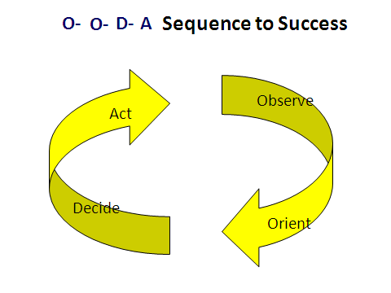Figure 1. OODA Sequence for Success

Why is this O-O-D-A yellow? –Because it’s a simplified version—a.k.a “O-O-D-A for Dummies©.” The actual OODA loop is a complex picture of feedback, feed forward, and control.

# The Issues

## Issue Number 1: Implementing a Strategy for Continued Competitive Advantage in War

That’s what this book is about. Echoing Deming, Boyd suggested that we substitute Appreciation and Leadership for Command and Control. But even to exert “Mission Command” demands the synchronization of these five issues over an “OODA” inspired continual learning process.

## Issue Number 2: Stuck in Single Loop Learning

Although we have had the NWTS process in place for over 10 years, we have not realized the synergistic effect of feedback through Lessons learned nor validated continuous improvement in producing mission readiness. When he took over at US Fleet Forces in October 2012, Admiral Gortney laid out his Vision for a Readiness Kill Chain (RKC). He thought that the end-to-end process for ensuring tight coordination across Fleets, SYSCOMs, and TYCOMs, and other partners throughout the readiness production battle space needed to be clarified.

## Issue Number 3: Lack of Systems Thinking and the Long View

Studies abound on the shortsighted approach taken by Navy Flag officers through the first decade of the 21st century. In the Surface Force, decisions to reduce manning, maintenance, and enroute training to save money have resulted in a decaying and barely Partially Mission Capable (“PMC”) force. Now we may not have enough money to buy more people, fix deferred maintenance, or reconstitute enroute schools. Without those resources, the Navy will slip into full NMC status.

## Issue Number 4: Regaining a Sense of Excellence

One old adage suggests that “Better is the enemy of ‘good enough.’” In the case of sustaining competitive advantage in warfare, that mindset will get you killed. We must always be prepared to get better- either by more diligently adhering to the published procedures and proven practices, or by finding ways to make them more efficient, clear, and effective, or completely revising how we see the problem and address it anew. Many times, we can develop training and education focused solutions with only an intellectual capital investment. This paper challenges you to make that investment immediately. Dedicate yourself to lifelong learning and a mindset of excellence. Really understand what we mean by meeting and exceeding performance expectations. Learn and execute the process to produce ever-improving results!

## Issue Number 5: Still not Aligned: A Proposed Set of Architectures for Alignment

Recall the magic word whispered from the shadows to Benjamin early in the 1968 movie *The Graduate*?

“Plastics”

What would that word be today?

I think it is “Architecture.”

DOD has been working since the early 1990’s on finding a method to align more of our efforts to meet all National Security requirements. Joint Pub 1 noted that success depends on “Unified Action.”

Unified action synchronizes, coordinates, and/or integrates joint, single-Service, and multinational operations with the operations of other USG departments and agencies, NGOs, IGOs (e.g., the United Nations [UN]), and the private sector to achieve unity of effort. The work involved aligning the Concepts, Strategies, Architectures, Organizations, Systems, and Procedures across all stakeholders in DOD. (JP 1, p. II-7)

Additionally, the concept must be extensible across all of government as well as allies, partners, and the private sector. When complete, a picture of the architecture will connect the dots-vertically and horizontally. Understanding the architecture will enable more to see the *Kaleidoscope’s* magic picture. The process enables integrating Lessons Learned into all of the capability-based processes and programs.

# The Readiness Kill Chain

"In support of CNO’s ‘wholeness’ concept and the three tenets of CNO’s Navigation Plan (Warfighting First, Operate Forward, and Be Ready),” Admiral Gortney wrote, “Fleet Forces has designed an integrated approach to the production and delivery of readiness. This approach will cultivate cross-Navy alignment, integrate decision-making processes, increase predictability, and enhance our effectiveness" (p. 1).

The Admiral continued, “Defined correctly, the RKC encompasses the entire Navy. Everyone is part of the RKC, and everyone must know and understand their place and role to influence all factors. The key to effective execution will be the ability for the Fleet to shape activities early enough in the RKC to maximize the relevance and quality of all inputs for the FRTP process” (p. 1). He noted that success depended on the strength of the working relationships among all Echelons, including the CNO and Secretariat staffs. Deming had previously noted: "Massive training is required to instill the courage to break with tradition. Every activity and every job is a part of the process." The RKC process would require the understanding and codification of key supported and supporting relationships with the TYCOMs, SYSCOMs, CNIC, OPNAV, and SECNAV.

Admiral Gortney saw the RKC not as a single chain, but as a series of linked processes- with evaluation and assessment and feedback part of a continuous improvement cycle. The Admiral noted that although assessment was the final piece of the RKC, it was really the beginning of how to increase effectiveness and maintain relevance in the production of readiness. “The RKC is actually an iterative process that must continually evolve and adapt to the environment. The ability to assess and obtain feedback from the warfighter will be the foundation of our readiness production” (p. 3).

Admiral Gortney’s concept of the Readiness Kill Chain can be viewed as an architecture focused on aligning all parties to harmonize to produce “capability standardization and warfighting wholeness” (Gortney, 2012, p 3). This paper presents the path to how we could implement the Readiness Kill Chain by understanding mission architectures and executing key performance improvement processes already in place. Success demands an intellectual capital investment from us all.

# Background- A Capabilities-based Force- Adaptable, Flexible, Responsive

Architecture development must start with planning and move through policy to objectives and strategy, incorporating ends, ways and means as Admiral Gortney’s vision articulated so well.

Well, “**What if?...”**

…We already had a process in place to implement the Readiness Kill Chain… that can be applied across all domains and at any level:

And, enables Commanders to:

* Develop reusable mission architectures that can emphasize effectiveness as well as efficiency.
* Incorporate best practices and Lessons Learned and
* Drive continuous improvement and focus innovation.

Plus, the system produces, balances, and updates:

* Aligned expectations
* Mission Readiness and Performance data
* MOPs/MOEs- “Metrics that Matter”
* Future systems/ capability requirements and “DOTMLPF-P solutions
* AND, can equip us for Mission Command!

### For the Navy: NMETLS and NWTS can be the aligning Holy Grail!

**BLUF:** NMETLs and the NWTS process equip commanders with four V’s to execute the Readiness Kill Chain. They help us:

* **V**isualize the mission
* **V**alue the contributions
* **V**erify progress, and
* **V**alidate COAs.

To those who know, the concept of mission analysis (USMC now uses “problem framing”) and the system of Navy Mission-Essential Task Lists (NMETLs) embodied in the Navy Warfare Training System, cover and align all of the fundamentals of the Readiness Kill Chain and continuous improvement processes for sustained success.

## Planning

It starts with planning. We must grasp the concepts of policy, objectives, strategy, and understand ends, ways and means. Policy provides overarching guidance, limits, and authorities. Strategy connects ends, ways, and means. *Ends* are the goals or objectives of an endeavor.

For the sake of continuity, I will use the term “mission” to represent any endeavor. Missions can be national, organizational, or personal, the process we will learn can be applied at any level for any mission.

A *Mission* clearly states the task and the purpose of an endeavor (Joint Pub 1).

*Ways* define how we may employ various means to accomplish the mission. *Means* are produced from the available technology. *Ways* and *means* are the “*How*” of the Conduct of war. In DOD language, these *ways and means* have been defined as a “system” with factors known in shorthand as “DOTMLPF.” .

### Capability and Capacity from DOTMLPF-P

The two key constructs are “Capability” and “Capacity.” *Capability* means we can do the tasks and *Capacity* means we have enough of each capability. In DOD capability language, “DOTMLPF-P” (Doctrine, Organization, Training, Materiel, Leadership Development and Education, Personnel and Facilities, plus Policy) are the components that make up every system. In a systems thinking construct, within each system there are “DOTMLPF-P” components; e.g.:

* Within the Doctrine system, there are DOTMLPF-P components.
* Within the Organization system, there are DOTMLPF-P components.
* Within the Training system, there are DOTMLPF-P components.
* Within the Materiel system, there are DOTMLPF-P components.
* Within the Leadership Development system, there are DOTMLPF-P components.
* Within the Personnel system, there are DOTMLPF-P components.
* Within the Facilities system, there are DOTMLPF-P components.

Policy may affect many DOTMLPF-P components.

DOTMLPF-P can be visualized as “ribbons” or “threads” tying the system, a system of systems, or families of systems together.[2]

### How do you get things done? This is the basis for a Plan.

The bottom line is getting things done. But not just doing things, we must ensure they are the right things, in the right ways, and with the right cost. One mindset that may help is defining a “mission focus.” Although martial in origin, great “missions” such as the construction of the Transamerica railroad- in the 1860’s or the endeavor to “Place a man on the moon by the end of the decade” in the 1960’s served to focused all involved on the national objective. Fifty years later, can we define the national mission?

Let’s at least start by a return to systems thinking and try to incorporate ideas from Deming, mission concepts of planning, execution, and assessment, recent Congressional initiatives, advances in learning and leadership theories, and applications of information related capabilities such as systems of systems and integrated architectures.

This short list can get us started on a Plan:

1. Set Goals. From our understanding of the mission (assigned or assumed), we can arrive at the objectives and intermediate objectives- goals.
2. Break into steps. We will have to motivate, monitor, correct, rejoice …i.e.: lead!
3. Assign tasks- estimate the cost.
4. Measure progress- Count the cost.
5. Adjust when necessary
6. Assess
7. Follow-up and follow through.

### Now, how do we know we can get things done?

1. You have the Capability to do the tasks- Capability means you can do it because you have the means and ways-- it includes competence, proficiency, and sustainment.
2. You know how soon it can be “Ready”
3. You have enough of the Capability
4. You know how long it will last
5. You know how to value it when aggregated with other Capabilities- “Interoperability/ integration”
6. You know where to “push” to improve the capability- Making it better
7. You know how soon it can be “recovered”- What that will cost!- How to get it ready again, once it’s been used

## Two key words: Capability and Capacity

Capability means you know you can do it. Capacity means you have enough of it. These two factors must become part of our systems thinking mindset. DOD and the services now have Policy in place to effect major performance improvements- real TRANSFORMATION**. But we don’t know it!** The Fleet Business Course at Monterey did not cover any DOD or Navy transformation process; especially the ones focused on training and readiness.

This book is my attempt to close that gap.

### Deming and Shewart Cycle- Driving for Excellence

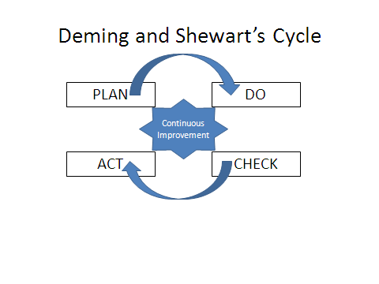In the 1990’s the Navy stressed Deming and Total Quality Leadership (TQL). Total Quality Leadership based on Deming’s model of the Shewart cycle is a four-step process of Plan-Do Check-Act to drive continuous improvement.

Figure 2. Deming and Shewart’s Cycle

Two additional concepts have been added t

LEAN (SIPOC) Suppliers-Inputs-Processes-Outputs-Customers

Six Sigma (DMAIC) Design, Measure, Analyze, Improve, Control

Most recently SECNAV has been imploring us to implement “Lean- Six Sigma” (”LSS”).

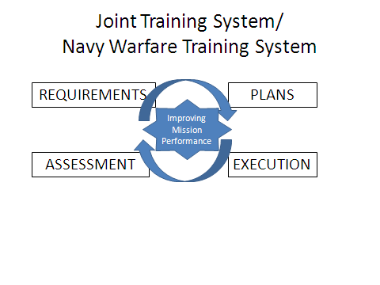We note that its formalized process of measuring and analysis provided feedback for an engineered system. It is also the model selected to describe the Training Process: Requirements-Plans-Execution-Assessment.

Figure 3. Joint/ Navy Warfare Training System

### LEAN thinking- Driving out waste

An advance on Deming’s model was the concept of LEAN- aimed at reducing waste. By using a simple mnemonic- SIPOC- and focusing on the customers - the ends of the mission- LEAN creates value streams defined by the SIPOC functions. Placing each function under analysis may uncover ways to drive out waste or innovate on the product.

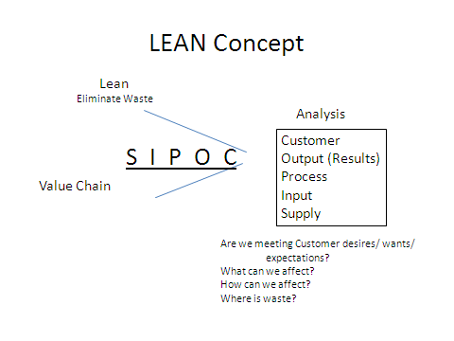Figure 4. LEAN Concept

Lean operates by focusing on each specific node moving from Right to Left (This is in keeping with the fact it was taken from Japanese thinking).

C = Customer demand- what does the customer really want? Satisfied? Or Pleased?

O = Output- How close is the output to what the customer values?

P = The Process leading to the output- does it produce what is needed/ desired- can it be improved?

I = Inputs coming into the Process- how are they sustained?

S = Supply of the inputs- what can be done to monitor/ control them or get them “better”?

### Six Sigma- Reducing Variation

Following on the heels of LEAN, the concept of Six Sigma strived to drive out 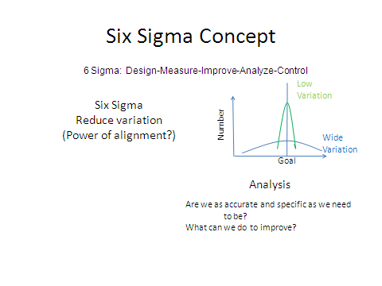variability. The system can be controlled to drive continuous improvement.

Figure 5. Six Sigma Concept

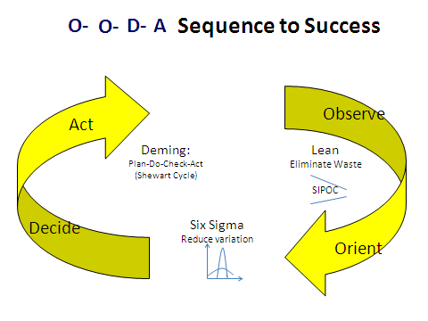**Integrated Views.** Begin to integrate these views: into the OODA process to understand the synergistic effect of clarifying performance expectations and being aligned top to bottom.

Figure 6. Integrated View

### Understanding Good Performance and Doing it

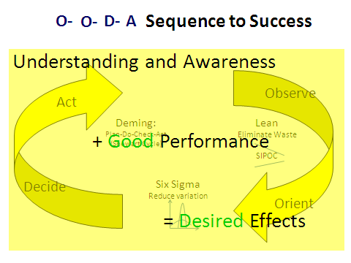It doesn’t matter what process you are executing, whatever it is they all depend on an understanding and awareness of what good performance is- what it looks like- how we will know- coupled to good performance to get us where we need to go- produce the results/ effects/ and meet the commanders’ expectations.

Figure 7. Knowing What’s Right and Doing It Right for Mission Success

Desired Effects can be replaced by “Desired Results” to get the message across.

The key thing is improving mission performance!

## Continuous Improvement Ascends on a Growing Knowledge Base

**Problem:** Implementing continuous improvement -focused programs including the DOD Transformation, the Joint or Navy Warfare Training System (JTS/ NWTS), the Defense Readiness Reporting System (DRRS), and the Navy version of the Defense Readiness Reporting System (DRRS-N), depends on educated, trained and knowledgeable practitioners dedicated to achieving the Enterprise goals and intertwined objectives for operational primacy and mission effectiveness. However, there is no formal process to produce certified practitioners.

Any continuous improvement process flows from expanding the knowledge base of its practitioners. A good “Continuous Improvement System” would have a Performance Improvement curve shaped as shown- but its projection and growth depend on an ever-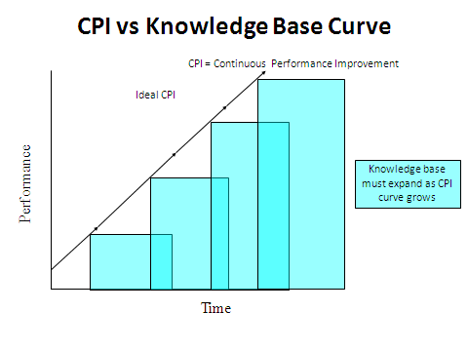expanding knowledge base of understanding and awareness of what “good” is.

Figure 8. CPI vs Knowledge Base Curve

Moreover, when one has achieved mastery, remember there is a decay curve working-- for a ship, the gear is one day closer to failure, or a key person, one day closer to transfer, or a new DOTMLPF-P system is coming with the promise to improve performance- but with a cost to learn…..

We must build a system that continuously refreshes and expands the knowledge base as it improves mission readiness and mission performance. Moreover, even when one achieves mastery, remember there is a “decay curve” working-- for a ship, the gear is one day closer to failure, or a key person, one day closer to transfer, or a new DOTMLPF-P system is coming with the promise to improve performance- but with a cost to learn. Do we ever lose all of the competency we have developed? That depends on the nature of the knowledge, skill, or ability we have mastered- and the changing environment. How universal is the concept?

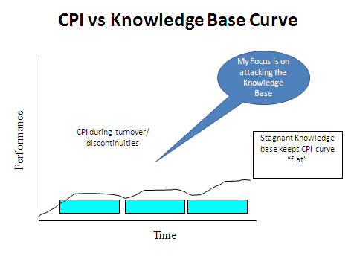Flash: Could this apply to the mission of education as well?

But what happens if the system itself undergoes discontinuities?

Figure 9. CPI with Stagnant Knowledge Base Curve

The CPI knowledge base remains stagnant if we constantly change leaders who don’t grasp the vision or we don’t take the time to make the intellectual capital investment to comprehend how the system should be working. This lack of knowledge stagnates attempts at improvement.

However, if we cold harness the system and create that “profound knowledge” Deming spoke of, we can go from A to B: (Truly TRANSFORMATIONAL!)

 A B

Figure 10. “Transformational Gain” with a Growing Knowledge Base

**CNO Guidance: Learning Organizations**

Throughout the new century, CNOs have proclaimed as key goals alignment and accountability through the development of a learning organization. When Admiral Mullen took over as CNO back in 2007, he directed Commander, U.S. Fleet Forces (USFF) to conduct a “strategic review” that, among other products, would produce “NMETLS” for emerging missions and capabilities, which include standards compatible with joint readiness reporting requirements.[3] – “What?”

### *What exactly is an NMETL and where did they come from?*

A Navy Mission-Essential Task List (NMETL) is a comprehensive command and mission specific list of Navy Mission-Essential Tasks (NMETs). More Jominian in concept, but demanding of the Clauswitzian Coup d’oeil in application, “NMETLs enable a commander to quantify the level and scope of effort required to achieve mission objectives.”[4] NMETLs are the centerpiece of a continuous improvement process or double-loop learning expressed in the Joint Training System (JTS) that inspired “Navy Warfare Training System” (NWTS).[5] From a War College perspective, the “METL” actually is a “Nature of War vs. Character and Conduct of War” principle.[6] System encompassing NMETLs clearly state mission requirements on which all continuous improvement processes can focus.

Navy Leaders responsible for alignment, setting expectations, driving continuous improvement, incorporating lessons learned and best practices to focus innovation, should understand the NMETL-NWTS concept and its applications to our quest for “Fleet Integration” across the Readiness Kill Chain.[7]

In December 2005, the CNO message entitled “Anchoring Sea Enterprise”[8] listed five key fundamentals for sustained efficiency and effectiveness:

1. Senior leaders must drive transformation by setting aligned expectations.
2. Leaders must create a continuous improvement culture by defining and measuring outputs, balancing risks and ensuring accountability.
3. Navy-wide alignment of organizations and processes must share best practices, leverage core competencies, and become more efficient and effective.
4. All must embrace best practices and employ lessons learned in a continuous improvement process.
5. All must develop “business acumen.” **Leaders must become knowledgeable about the systems and processes leading to greater efficiency and effectiveness.**

This message also stated five steps in the Way Ahead for success in Sea Enterprise:

1. Know your business.
2. Dig into your processes.
3. Focus on efficient delivery of value.
4. Create a culture of innovation.
5. Capture savings.

Further, in CNO Guidance for 2007, he exclaimed, “Focus on “Execution!”**[9]** Admiral Harvey enjoined as he took over U.S. Fleet Forces in July 2009: “Be brilliant on the basics. Maintain Standards!” and *I* heard him say: “Focus on the Funda-METLs.” Our current CNO, Admiral Greenert has chimed in “Warfighting first, Operate Forward, and Be Ready.” Admiral Gortney developed the Readiness Kill Chain to achieve these goals.

### “Transformation” has gotten a bad rap- We must Repent!

In the Bible, people hear “Repent” and think they must stop sinning and feel bad. In reality, to “repent” means to turn your thinking around - to change your mind. DOD should adopt this same focus. The “Transformation” we seek is to “Turn our thinking around- change our minds.” We must focus on excellence and ensure we stay ahead of the challenges either by anticipating them or by responding in ways that advance our national interests.

### Transformation to a Learning Organization Must Continue

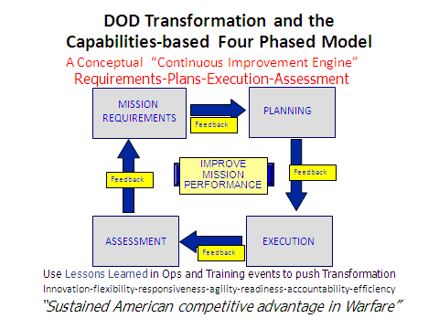Transformation can be visualized as running on a four-phased “continuous improvement engine” fueled by lessons learned (Figure 11). DOD Transformation’s website described it thusly: “Transformation is foremost a continuing process that does not have an end point. It is meant to create or anticipate the future…. The overall objective of these changes was simply – sustained American competitive advantage in warfare.”[10]

Figure 11. DOD Transformation on the Four Phased Model

*Transformation* is focused on changing the way we think, fight, approach warfare: The “character and conduct”--- not its “Nature.”

The Defense Readiness Reporting System[11] and all new joint capabilities require METLs or MET-like descriptions for expressing mission performance requirements. The Navy Warfare Training System (NWTS) employs NMETLs as the basis for fleet training programs.

However, NMETLs are considerately more applicable, comprehensive, and enlightening than just being used for Fleet training! Let’s look at the learning organization process and learn how the UJTL/UNTL and METL serve this transformation engine and the Readiness Kill Chain.

### Development of the Learning Organization

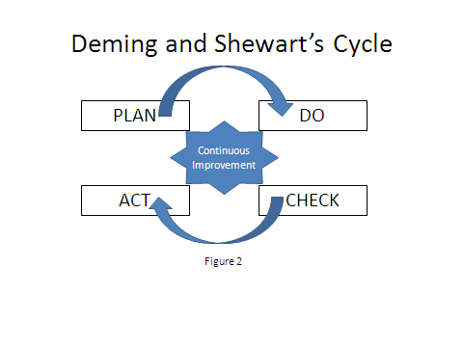It is all about improving mission performance. The Joint Training System process combines the best of several processes including Senge’s The Fifth Discipline and Argyris’ Double Loop Learning as well as Deming’s (Shewart’s) Cycle for continuous improvement.[12]

Figure 12. Deming and Shewart’s Cycle

### Joint Training System Process

DOD developed the Joint Training System a four-phase process of Requirements, Plans, Execution, and Assessment synchronized and executed continuously to drive improvements in mission performance and raise mission readiness.[13]

Figure 13. Joint/ Navy Warfare Training System

### War College 101

The gouge from the War Colleges is “It’s only a lot of reading if you do it.” That said, some basic concepts can be covered quickly. Boyd discovered what he termed “Patterns of Conflict.” As such, the big ideas support the long held philosophy on the nature, character, and conduct of war. The *Nature* of war is immutable, unchanging. But war is made up of two components: the *Character* and *Conduct*. The character is *who* is fighting and why they fight. The conduct is *how* they fight. And the *Character* and *Conduct* of war are always changing. And the fact that the character and conduct of war are always changing is part of the nature of war.

The other important aspect is Clausewitz’s concept of the “remarkable Trinity of Passion, Reason, and Chance.” Often, folks with a linear systems perspective fail to account for passion or chance in predicting the system’s response. Careful mission analysis or “problem framing” as used the by the USMC, can help commanders avoid that blindness. Remember the adversary always has a vote.

Moreover, Clausewitz also postulated, “War was the continuation of Policy with other means.” It’s that premise that enables the concept of the task library and the METL framework for universal applications! We can employ the NMETL framework across all systems, organizations, functions…..(the entire DOTMLP-F spectrum!) to visualize, value, verify, and validate mission performance, readiness, and accomplishment.

Produced through continuing mission analysis, NMETLS create aligned expectations and focus all efforts for continuous improvement in mission performance. We can envision a virtual “Continuous Improvement Engine” through the four phased model of Requirements-Plans-Execution and Assessment.” In so doing we enable the sharing and strengthening of our core missions—the “Essentials!” That understanding led to the recognition of the six fundamental functions of war: Command and Control, Movement and Maneuver, Intelligence (Understanding), Sustainment, and Protection. Finding or specifying a “common language” – a “Taxonomy– to align these efforts is the keystone for architecture development. We are seeking a method that stems from the Planning Process. We follow the mantra “Top down planning - Bottom up execution.” The process is collaborative, participative, and interactive. Strategy occurs at many levels. National strategy is termed “Grand Strategy” as laid out in Joint Doctrine Pub 1. The National Security Strategy and the National Military Strategy follow it, then on down the chain as others craft their vision to articulate how they plan to “achieve the integration of ends, ways, means.” These strategies are “Linked” through various levels and programs with organizations. Following this pattern will produce the key desired attributes of “Aligned, 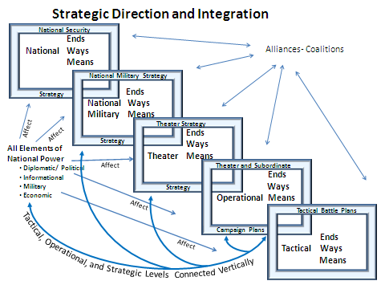interoperable, and synchronized” programs, processes, and capabilities.

Figure 14. Strategic Direction and Integration

This process is one solution to the “Tire Swing” dilemma. How can we put the vision of the tire swing in the lower right hand box onto every one of those trees? Common taxonomy, 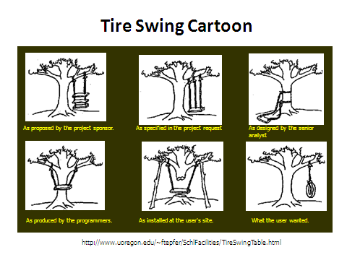common framework, common processes can effect the singleness of purpose and the common mindset as we seek to align goals, roles, and missions throughout the force.

Figure 15. Tire Swing Cartoon

### Advanced OODA loop

The OODA diagram must be studied and expanded from the basic systems approach of the Plan-Do-Check-Act (PDCA) model to one that begins to consider a wider background of heritage, personality, culture, shocks, and developing surprises across the whole range of the environment. The picture operationalizes much of the theory on Organization Culture advanced by Eric Schein (1989) and Porter ‘s (1984) description of the Five Forces acting on an organization. These ideas eventually made their ways into Joint Warfighting Concepts of the Operational Environment. [14]

Boyd continued to study and constantly refine his OODA model by extending his knowledge from the thermodynamics and fluid flow regimes of fighter tactics all the way through the history of warfare (Patterns of Conflict[15]), scientific discovery, decision and control theories, and technological innovation to construct the model to sustain National Security Strategy. Chet Richards, a dedicated acolyte termed it “Certain to Win.”[16]

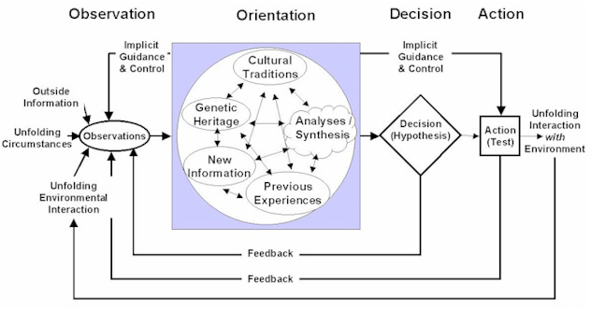To appreciate fully the implications of the model, one must start from the basics of knowing the objective, clarifying the mission to all concerned, planning the path, and beginning the journey.

Figure 15. Advanced OODA Loop

Above is Boyd’s last version and the one that is most representative of the long view and adaptable as advances in science, technology, national objectives, and adversary initiatives occur. In looking for ways ahead, one must seek natural patterns for survival and continued competitive advantage. In military think, we mean “Dominance.”

## The Context - Why the UJTL?

What plans would the historical Hannibal, Caesar, or Napoleon or a modern Nimitz, Burke, or Greenert make to **move and maneuver**, **gather** situational **awareness**, **employ their capabilities**, **sustain**, **command and control,** and **protect** their forces? When you break it down, their “tasks” were not that much different from what we must do today- just the systems, and our tactics, techniques and procedures (TTP) have changed to meet the new threat or operating environment.

In new DOD terminology, these six areas characterize the “Elements of Defense Transformation”[17] and also represent the “Nature of War” based framework of the Universal Joint Task List (UJTL).[18] *Tasks* are described to a “universal” understanding across organizations and missions. Using conditions and standards, we transform mere tasks into “METLs” to fit the circumstances- the character and conduct of war. METLs allow commanders to visualize integrated operations.

### Linking Integrated Operations- Whole of Government- to the GPRA

The strategy-to-task mission analysis process described in the UJTL reflects a growing understanding of the new, wider definition of jointness (now "integrated") and offers a pathway for the executive branch’s combined response to meet the requirements of the Government Performance Results Act (GPRA) of 1993.

Congress enacted the GPRA to solve perceived problems with the federal government’s performance and accountability. Designed to improve the American people’s confidence in their government, the GPRA established strategic planning and performance measurement across all departments. The GPRA systematically holds Federal agencies accountable for achieving program results. The GPRA specified that Executive Branch entities would Set program goals, Measure program performance against those goals, and Report publicly on their progress.

The combined effects should be to raise the accountability and promote the efficiency and effectiveness of the federal government. Many think tanks and leaders began to develop systems to track and display progress such as Balanced Scorecards and “Dashboards.” The METL process reflects a proven method to fill in the sections of these new tools to meet GPRA as well as align integrated mission performance requirements and pursue evidenced-based management! That will really lead to “One Team, One Fight!”

**Bumper Stickers**

**“Accountability”**

**“Transparency”**

**“Cost-wise Readiness”**

**“Efficient Excellence”**

**“Metrics that Matter!”**

Figure 16. Bumper Stickers

This system of task libraries enables the overall mission architecture to be developed. We should approach assembling the mission architecture through the Mission Analysis-NMETL process. Moreover, METLs are an established method to integrate, synthesize and evaluate the new joint-interagency-intergovernmental-inter-service- team for conducting the full range of integrated operatio*ns.* The UJTL provides the building blocks to link strategic direction and integration both from the top-down and across and identify all the potential interactions and interferences impeding excellence. The process also uncovers support available and required to equip our allies/ coalition partners for success, and interoperability.

Figure 17. Mission Architecture Building Blocks

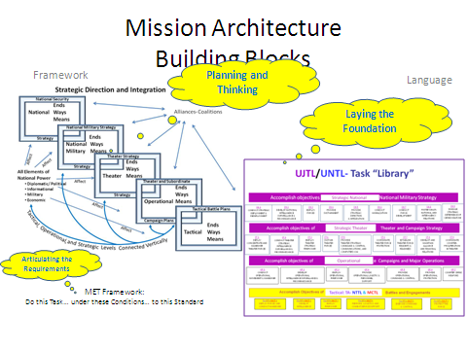The building blocks are the METL Framework and the language of the UJTL. In the future, as the national security architecture develops across the interagency and executive branches, an even more comprehensive list can be developed.[19] The continuous improvement/ transformational/ innovation process can remain the way ahead.

# Seven Steps to NMETL Advocacy

Navy leaders must become “NMETL Advocates” by following the seven-step method outlined in the following chart:

**Seven Steps to NMETL Advocacy**

1. Learn the Framework and the Language
2. Drive for the Standard
3. Appreciate Conditions
4. Grasp “Universal”
5. Adopt the Process
6. Practice-Execute the NWTS
7. Refine your “Coup d’oeil”

Figure 18. Seven Steps to NMETL Advocacy

The process will be explained, illustrated, and leaders will be challenged to step ahead toward an NMETL’d way of commanding and controlling- or as Boyd would implore- of *Appreciating* and *Leading* the future force.

## 1. Step One: Learn the framework and the language.

Understand the background of the UNTL-Mission Analysis-NMETL framework and the new mission performance language of METLs.

Most of us who have been involved in mission analysis and fleet training over the past several years understand the aligning power of the Mission-essential Task List (METL) as described in the Universal Naval Task List (UNTL).[20] Current advances in readiness reporting, adaptive planning, and developing joint capabilities are already steaming at full speed along the METL track.

### **Where did METLs come from?**

METLs represent a universal manner to express mission performance requirements. The U.S. Army took a systems perspective in designing their “Blueprint of the Battlefield” as a family of Battlefield Operating Systems. They developed “Mission Essential Tasks” by aligning mission orders to the individual, team and collective tasks their units must execute for success. At the same time, the advances in information technology created “reusable objects” to craft into adaptive packages. The idea of a mission architecture was born.

In the early 1990’s as the Joint Staff focused on redefining the Department of Defense’s missions as the spotlight shifted from Cold War containment to new future operational plans, each Combatant Commander (CCDR) presented an OPLAN covering their specific assignments. Although many of the principle responsibilities were similar- and each plan required support from “specified” commanders, each expressed different terminology to describe a similar function. For instance, each CCDR knew they needed to augment the force structure in theater as part of the Flexible Deterrent Options. However, one said, “Move forces to my AOR.” Another said, “Transfer forces to my command.” Yet another said, “Send me the Marines!” There was not a common standard to express the mission performance requirements. To improve interoperability and speed the planning and deployment procedures, Joint Staff established the idea to develop a common lexicon through the doctrinal process. The first document to assist planners was the task library and framework described in the Universal Joint Task List.[21] “Centralized planning, and decentralized execution” never had it so good!

Figure 19. How Central Has “METL” Become?

### Amazing Alignment and UJTL Centrality

The UJTL has evolved into the central and unifying force prescribing how we can plan, train, fight, assess, today and define requirements for the defense systems of the future. The UJTL is a ***library*** or ***menu*** of tasks in a common language that serves as the foundation for capabilities-based planning across the range of military operations (ROMO). “The UJTL supports DOD in capabilities-based planning, joint force development, readiness reporting, experimentation, joint training and education, and lessons learned.”[22] The UJTL has become the focal point for DOD Transformation. At the Office of the Secretary of Defense (OSD) level, four major programs call for the expression of capabilities or mission performance requirements in the METL terminology of tasks, conditions, and standards. Training, Readiness Reporting, Capabilities Development, and Adaptive Force Planning, all revolve around the language and framework described in the UJTL. DOD Military Training is based on METs, prioritized to potential operations to enable mission rehearsal, and employs lessons learned from recent tests, experiments, war games, operations and other training events. The Joint Training System (JTS) (which is the same process employed in the Navy Warfare Training System (NWTS)) when run as conceived/ directed, enables a continuous improvement process (CIP) fueled by lessons learned from operations, training and experimentation. Additionally, feedback can focus innovation and experimentation to improve mission performance.

By expanding the JTS process from just training to incorporate almost every phase of the readiness process, Admiral Gortney’s Readiness Kill Chain emerges - whether one takes a resource focus (PESTOF) or Systems view (DOTMLPF-P). The whole objective is to improve the way the Navy produces mission ready Forces. The full operation of the process will ensure those force are focused on improving performance and building adaptable excellence.

The new DOD Readiness Reporting System (DRRS) captures readiness indicators based on an organization’s “METs.” We note a rise in readiness when the unit or staff demonstrates it can perform the MET better. That means it meets standards under a more difficult conditions set, or that it continually exceeds standards when performing under the nominal conditions set. In fact, as we apply specific “DOTMLPF-P” solutions to improve task performance; we can track the change in performance caused by the solution applied. For example, as we apply a “T”-focused solution—through a school, training exercise, practical demonstration, etc. —we can ascribe the rise in task performance to that specific solution.

Joint Capabilities Integration and Development System (JCIDS) and DOD 5000 series directives dictate the expression of future capabilities as sets of tasks, conditions, and standards. Further, Capabilities-based planning guidance also points us to the language and format for expressing mission requirements as METs as we assemble adaptive force packages to meet a Combatant Commander’s (CCDR’s) “Request for Capabilities” (RFCs).

### The UJTL and UNTL: “Task Libraries”

Using the common terminology and framework from the UJTL, commanders describe their mission-essential tasks to a "universal" understanding across DOD including Combat Support Agencies and the National Security arena, and perhaps in the future, government wide. This process is the path to completely integrated operations- “Unified Action”- per doctrine! The UJTL includes the strategic, operational, and joint tactical tasks plus each service, agency or other organization task libraries. The latest Universal Naval Task List (UNTL Version 3.0) includes both the Navy Tactical Task List (NTTL) and the Marine Corps Task List (MCTL).

UJTL = SN-ST-OP-TA Tasks + Service Tasks

UNTL = NTTL + MCTL

Figure 20. UJTL and UNTL

Note that the UJTL/UNTL serve as a *Task Library,* much like the DOD Dictionary serves as the basis for terms of reference, and covers the full range of military operations from disaster recovery operations to winning the fight against terrorism or succeeding in Building Partnerships.

Tasks in the task libraries follow the same format. Strategic National (SN), Strategic Theater (ST), Operational (OP), and Joint Tactical (TA) tasks, as well as Navy Tactical Tasks (NTA), all have a nomenclature (SN 1.1, ST 2.3, OP 4.5, TA 3.2, etc), title, description (formerly “definition”), and doctrinal reference documents. Example:

**SN 1.1.2 Coordinate and Match Transportation Resources and Requirements**

To compare deployment requirements against the actual strategic lift assets made available. If a change in the allocation is required, the supported combatant command, in coordination with USTRANSCOM, requests additional transportation allocations from the Chairman of the Joint Chiefs of Staff. (JP 4-0, 4-01, 4-01.1, 4-01.2, 4-01.3, 4-01.54-01.7)[23]

…and a Sample Task from the UNTL:

**NTA 1.1 Move Naval Tactical Forces**

To move naval units and/or organizations and their systems from one position to another in order to gain a position of advantage or avoid a position of disadvantage with respect to an enemy. (JP 3-0, 3-02, 3-02.1, 3-15, MCDP 1, 3, NDP 1, 4, NWP 1-02, 3-02 Series, 3-20.6, 4-01, 4-01.4)

These “mission” tasks (e.g. STs/ NTAs/ MCTs) are "capital T" tasks as opposed to individual job- "little t"- tasks you might find in a Job Task Analysis (JTA), Personal Qualification Standard (PQS), or other assembly of tasks. Mission Tasks usually terminate where individual TTP steps begin.

### Remember- Tasks in the UNTL have rules:

Tasks are based on doctrine or developing concepts. Each task describes a discrete activity or event. Tasks do not specify **who** or **how**. Tasks do not define specific systems or pieces of equipment. Tasks do not describe environmental issues. Tasks do not need many adjectives or adverbs.

Additionally, tasks do not duplicate existing tasks. Tasks such as "Plan Air Operations, Plan Surface Operations, Plan ASW Operations, and Plan Maritime Interception Operations" are all included in the universally applicable and understood "NTA 5.3.9 Prepare Plans and Orders" task. Commanders use this NTA and select appropriate conditions and standards (measures + criteria) based on their command level, responsibilities, and available resources to complete their NMET.

### Using METLs for Continuous Improvement:

The UJTL-METL structures (UNTL-NMETL structures) are standardized tools for describing mission-to-task requirements for planning, conducting, executing, and assessing joint and Navy operations and training as well as any other attribute of the DOTMLPF-P system. NMETL systems can describe network foundations. The current UJTL is still “heat, blast and fragmentation warfare” centric. Advances to define and describe network actions and parameters must clearly inform commanders on their networks’ value, reliability, and performance.

Additionally, NMETL language can be used to frame required capabilities for force transformation, experimentation, and concept development. Moreover, NMETLs could serve as “evidenced-based management” platforms. NMETLS and the NWTS are LEAN SIX SIGMA ready! The Enterprise Architecture could be constructed on a METL frame. Using NMETs linked vertically and horizontally, supported-supporting relationships and performance measuring processes can be defined, refined, and continuously improved.

NMETLs have a static component when linked to the planning process to enable commanders to see clearly the relationships between originations and develop lines of communications and inter-dependencies. Once laid out in a flow chart diagram, NMETLs serve as the basis for the Master Scenario Events List (MSELs) employed in defining mission vignettes in the Training program. Exercises employing these mission threads can be broken down to analyze performance and understand exactly where to push to improve performance and mission readiness.

Linking feedback and Lessons Learned issues to NMETs starts the feedback process that will drive continuous improvement and focus future innovation. We need to close this loop!

### The Mission Analysis (Problem Framing) to NMETL Process.

Commanders build NMETLs through a detailed mission analysis process. It is a simple concept--the METL flows "downhill.” At every level, the mission analysis process is the same: review the directives, study the specified tasks, discern the implied tasks, determine essentiality, figure out what help you need, either from supporting commands (below you) or commands outside your chain, designate standards, and identify conditions that affect achievement of the performance standard.

Figure 21. The NAVY’s NMETL Process

Existing CONOPS can help develop early NMETLs; moreover, systematically developed NMETLs can lead to refined CONOPS. Both enhance the commander’s understanding of the mission.

The mission analysis process answers three big questions:

1. What do we really have to do?

2. How well do we have to do it?

3. What help do we need from outside our organization?

A commander's mission analysis should capture first, in language that is locally understood, what the mission tasks are, and then employ the UJTL/UNTL to translate those tasks into universal language. If the task library needs a new task, the commander nominates one to Navy Warfare Development Command (NWDC). An *NMET* consists of a task (usually NTA) performed by a Naval force and deemed essential to mission success, and includes performance standards linked to relevant conditions in accordance with guidance in the UJTL/UNTL.

*Operational Level of War view secret.* Begin METL development from the mission, to tasks, then assign to the responsible organizations (“RESP ORGs” in NMETL language). The UJTL shows it so.

Whatever you do, do not start just identifying tasks from the task library; that way you never review the mission assignment or the reason(s) behind the application of the capability.

### METL Framework.

"Perform this task... under these conditions... to this standard."

The METL framework includes the structure of the NMET statement:

Figure 22. The NMET Statement

It includes the “linkages” between participating organizations to “synthesize” the system.

**You should now understand the difference between the task libraries (UJTL-UNTL) and the METLs.** The library is available for all to employ as their mission dictates. Building the METLs puts selected universal tasks into context!

Figure 23. Mission Requirements Phase

### Networks- Making the Connections: “Linkages”

NMETLs do not stand on their own necessarily; NMETs fit into the overall picture of mission accomplishment for the force. After determining the Mission-Essential Tasks and the responsible organizations for those tasks, we assemble an NMETL for each "RESP ORG" and "Mission" in NTIMS.[24] A Strike Group Commander has an NMETL. Each of the warfare commanders and the functional coordinators has its NMETL and their units all have NMETLs. These must be "linked together" to fully understand (Boyd’s “Appreciate”) the mission. Links key network views.

We "link" NMETLs on a task-by-task basis between commands. We start from the top-down mission analysis and build task-to-task links to each level. A lower level NMETL has tasks that support higher-level NMETs.

Often, a junior's achievement of its NMET standard sets his senior's conditions for success. In METL language, tasks in the subordinate chain of command that support a commander’s task are ***supporting*** tasks. Senior’s METL Tasks that a junior's MET supports are ***supported*** tasks. Those tasks performed by agencies, the naval shore establishment, and other organizations outside the commander's direct control are termed "***command-linked”*** tasks Command-linkages demonstrate the value supporting commands add to mission success.

For example, Navy Meteorological and Oceanographic (METOC) organizations support combat organizations through command-linked tasks; these networked tasks show how supply and logistics organizations or national intelligence organizations support a local commander. In Navy vernacular, the Air Defense Commander (ADC) supports the Anti-Submarine Warfare Commander (ASWC), and vice versa via command-linked tasks.

Commander Naval Installations Command (CNIC), Naval Expeditionary Combat Command (NECC), and other Navy Readiness Enterprise provider organizations demonstrate their value through command-task linkages.

When the linkages are complete, you might have a “spider web-like” display of the operation, but you will have a clear framework to articulate current and future requirements. Using the Force-wide linkages of NMETLs, FORCEnet architects and developers could construct a capabilities framework against which to develop their engineering architectures. FORCEnet engineers will then be able to layout packages that integrate and optimize all elements of the Common Operational Tactical Picture (COTP) for Maritime Domain Awareness.

### The Mission Performance Language

Recent initiatives in readiness reporting, capabilities development, and further enhancements to joint—now “integrated”—operations, planning, and training confirm that “METLs” is the new mission performance language. You are now learning how to “METL” it!

## 2. Drive for the Standard.

Understand the METL “Standard” as a Measure with a Criterion. Moreover, tasks should have both process/ procedure-type measures as well as outcome-based measures, and may have more than one standard.

NMETL usage of the term *standard* differs from ISO 9000 standards. An NMETL *standard* consists of a "measure" and a "criterion."

#### STANDARD = MEASURE + CRITERION

Figure 24. The MET Standard Framework

The ***measure***reflects the indicator or parameter we want to monitor and collect. The ***criterion*** is set by the commander based on the assigned mission. For Navy core missions, standards have been set to ensure successful future task performance. We measure dimensions of performance using parameters such as times of flight, periods between events, numbers of casualties, accuracy of weapons delivered, and “ordnance on target.” Tasks may have more than one standard. To meet NMETL standards, we must demonstrate the ability to satisfy each measure to the specified criterion.

Some sample standards broken down into their measures and criteria are demonstrated below.

**Sample NMET Standards**

**Criteria** **Measures**

Less than 10 (Minutes) Minutes to recover a man overboard

* 1. (Seconds) Seconds between aircraft launches

>45 knots Sustained average speed for 1200 NM transit

>95 (%) Percent of planned air operations meet schedule

None Of ordnance delivered caused collateral damage

Yes All procedures followed

Figure 25. Sample NMET Standards

The UJTL/UNTL includes the following guidance for setting good METL standards:

1. Employ measures from a variety of categories: Input, Process, Output, and Outcome. All have value in setting goals and evaluating performance.
2. Focus on “Process” and “Outcome” (or *Product*) measures. (Inputs may add insight.)
3. Keep them “Simple, …”
4. Reflect the commanders’ guidance—their values set criteria!
5. Reflect an understanding of the task and its contribution to mission success.
6. Consider incorporating recent Lessons Learned to validate they have been learned.
7. Remain sensitive to impact of changing conditions on the measures—often this helps in narrowing the condition sets to choose for a MET. Standards must match the conditions.
8. Refrain from using only “Go-No Go” type measures. (Allows trend recognition.)
9. Use both absolute and relative scales.
10. Set *Criteria* by employing “capabilities” inherent in the DOTMLPF-P system design.

### And, remember: *Standards* drive performance!

NMET performance can be evaluated along at least two paths: Process or Procedure-focused measures and Outcome or Product-based measures.

-Process/ Procedure measures attempt to answer questions such as: “Were procedures and processes adequate? Were the procedures/ processes followed? Were the procedures even used?” Many Navy Lessons Learned focus on these issues. Process measures help Commanders monitor mission progress.

-Outcome or Product-based measures attempt to answer questions such as: “What were the results? How well was the task performed according to key performance parameters? Did the task contribute as much value as anticipated to mission success?” Commanders employ product measures to assess mission accomplishment.

Moreover, Input-based measures answer questions such as “How do we know we can do a good job?” Inputs help commanders know they are set up for success and ready to begin. DRRS-N and the enhanced Status of Resources and Training (E-SORTS) work in this arena to show the value of proper unit resourcing.

Let’s recall the UNTL discourages the use of binary measures such as Yes/No. Often, the task is repetitive so we should employ opportunities to record the percent of successful performance or the percent of objectives achieved rather than driving solely to “go/no-go” criteria when evaluating task performance. Good standards drive better performance. As leaders, we want to capture how we can ensure that our operators are employing proper procedures, learning from “Lessons Learned,” and implementing “best practices” in achieving “efficient excellence.”

## 3. Appreciate Conditions.

Consider, comprehend, and appreciate the effects Conditions have on performance. Changing Conditions also alter risk.

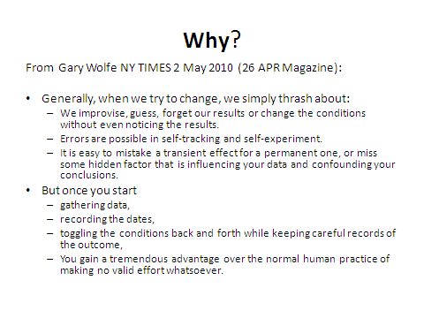Standards cannot be set in a vacuum. Page A-3 of the UJTL notes: “standards, when linked to conditions, provide a basis for planning, conducting, and evaluating military operations as well as training events.” Conditions matter: both in terms of how we prepare and train for mission success, and in terms of how we approach the expected environment we actually will face. METL conditions are chosen by “relevance” – either the selected condition affects achievement of the stated performance standard, or the condition bounds the range of the expected operational environment.

Figure 26. Why?

To understand the effects of conditions, consider the following example. A ship must be able to recover a man overboard, even in extreme conditions of winds, seas, and darkness. In that case, recovering the man without sustaining any other losses might be a good standard. However, in designing a training performance standard, the standard of recovering the simulated man overboard in less than 10 minutes is predicated on a more benign condition set.

Now let’s evaluate two ships in a training environment.

The first has a clear day with almost perfect seas and very light winds. It maneuvers to recover the “man” in 9 1/2 minutes.

The second runs its drill near dusk, with 5-7 foot seas and NW winds at 15-18 knots. It also meets the less than 10-minute standard, barely at 9:58.

Which ship is more ready? Under the old system, both look equal. Each met the standard; however, the second ship met the standard in a more challenging environment. Should it get greater credit for its achievement in a higher level of difficulty?

Readiness expectations should consider the effect not only of the conditions under which a unit gains task execution experience, but also be able to predict expected performance levels as the condition set changes. Under the old paradigm of readiness reporting, we said we were “ready” if we had all the resources aligned for success. “SORTS” is input-measures based.[25] Under the MET-based readiness approach, we describe our readiness to meet performance standards. We still employ resources, but also have developed ways to link these resource requirements with performance expectations to provide the confidence that we can meet the standard. Performance gaps can be closed by adjusting SORTS resources or the system (DOTMLPF-P) with new capabilities or more capacity.

Conditions help us understand the level of difficulty for task performance. METL language expresses conditions in three themes: physical, military, and civil. Other mission analysis (problem framing) practices use terms like “METT-TC” (mission, enemy, terrain and weather, troops and support available, time available, and civil considerations), or PMESII (Political, Military, Economic, Social, Infrastructure, and Information). The UJTL/ UNTL Conditions Library enables any of these views to be expressed in MET “Task, Conditions, Standards” statements.

Appreciating NMETL conditions also helps commanders quantify “risk.” Through our training and mission rehearsal efforts, the commander gains confidence in NMET performance in anticipated conditions (as specified in the NMET). Commanders must determine the effects a new environment will have on future performance and evaluate the new "risk" based on an analysis of future performance against the updated condition sets.

Commanders also use “conditions” to describe pre-states, mid-states, or end-states of the mission. “Effects” and conditions occupy the same “space” or “system state” – the operating environment. In an “Effects-based” thinking approach, effects are changes in the system state or conditions. Effects result from actions such as task performance or environmental changes.

Conditions and effects also can be grouped by “who has control.” In some instances, I can set the desired conditions; at other times, the adversary sets the conditions; and often, neither of us has control of some conditions (e.g. weather). Likewise, in observing “effects,” I can choose my response to observed effects; the enemy can choose the way he responds to (and orients to observe) the effects from his perspective, and other times, no one can control how third-party participants in the condition space may respond to the change.

Further, I may choose to design “effects” -a change in state (the conditions) - to convince an adversary to choose a specific COA. However, that adversary may recognize other options besides the COA I desired him to choose. He always has the option to refuse – see Eddie Izzard‘s “Cake or Death” skit for further explanations.

## 4. Grasp “Universal.”

*Acknowledge the big picture of the “Universal-ness” of the NMETL format. ROC-POE, system design specifications, and all other requirements tools can employ the METL format of Tasks, Conditions, and Standards based on the common language of the UNTL. CONOPS and NMETLs are mutually supporting.*

NMETL Advocacy recognizes the universal applicability of the concept for leading and managing at any level. Our universal application of NMETLs can encompass all support for continuing transformation, Fleet Integration, and Readiness Kill Chain. Every new Navy warfighting improvement enterprise such as the Warfare Centers of Excellence, Task Force ASW, Task Force SIM (Simulation), SEA TRIAL, and Task Force Warrior should be integrated into the NWTS process. OPNAV should revise organizational Required Operational Capabilities- Projected Operating Environment (ROC POE) listings into METL language.

Mission Capabilities Packages (MCP) and Fleet Collaborative Teams (FCT) can be organized to provide support to appropriate NWTS phases and improve their products. CONOPS development can employ the Mission Analysis to NMETL process to lay the foundation for expressing the commander’s plan for mission accomplishment.

Commander Naval Installations Command (CNIC) has incorporated the NMETL and NWTS process into assessments for facilities’ readiness. Commander Operational Test and Evaluation Force (OPTEVFOR) has begun to integrate the NMETL process into test plans and should be included in the NWTS. Naval Sea Systems Command (NAVSEA) and the other systems commands and the Board of Inspection and Survey (INSURV) could also benefit from force-wide alignment to the NMETL construct of “Perform this Task …under these Conditions …to a Standard of ….”

To implement Fleet Integration, a Title 10 NMETL could be developed to support the 10 missions of the new National Military Strategy that links all elements and echelons. Thereby, clear chains for accountability and mission accomplishment could then be identified, analyzed, verified, and optimized.

### Back to Clausewitz and Integrated Operations.

Recall Clausewitz’s notion that “War is a continuation of Policy with other means.” Doctrinally, we discuss several instruments of national power-usually known as the “DIME” concept. The United States employs ***diplomatic***, ***information***, ***military*** and ***economic*** power to shape the world environment. National Security Strategy[26] documents describe how these instruments work in synergy to sustain American values and influence. To fully assemble a model for integrated operations across all instruments of national power, (“Unified Action” in doctrine), a “universal” task library could be constructed along the same six functions of movement, situational awareness, employment of capabilities, sustainment of those capabilities, command and control (Boyd’s “Appreciation and Leadership),[27] and protection.

Let’s explore the process!

## 5. Adopt the process.

*Understand the Four-phased continuous improvement process of Training Transformation (T2) through the Joint Training System & Navy Warfare Training System: Requirements-Plans-Execution and Assessment.*

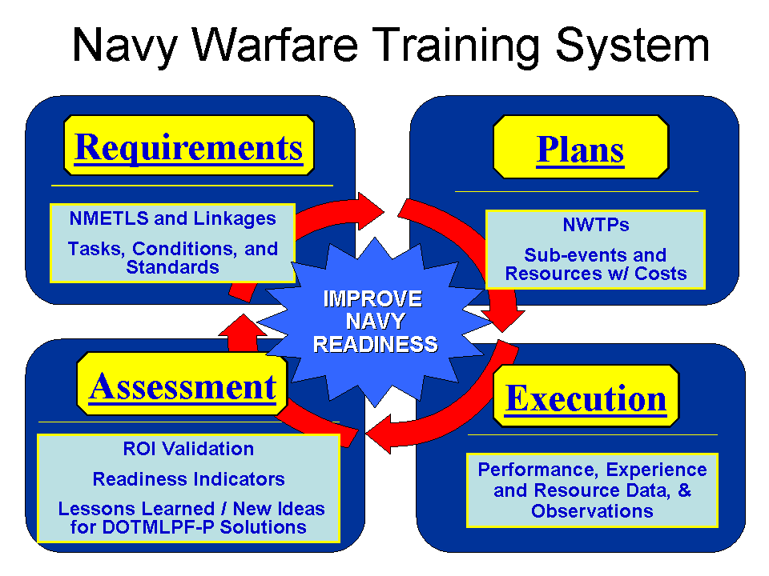DOD’s Training Transformation (T2) is running on a conceptual “continuous improvement engine” fueled by Lessons Learned and other ideas generated from training and operating events, as well as projected future mission analysis. This transformation engine operates continuously where all of its phases are being conducted simultaneously: METLs are continuously refined, future planning is happening in the midst of execution, and assessments are updated and reported near-real time. This concept represents the foundation of the Capabilities-based system of systems and could become the foundation of the Readiness Kill Chain.

Figure 27. The Navy Warfare Training System Framework

The NWTS, modeled on the JTS, provides a systematic four-phased approach to transforming Fleet training and operations. Commanders employ the NWTS to express mission-based capability needs (NMETLs) in the Requirements Phase; identify and codify prioritized training requirements in a progressive and synchronized Navy Warfare Training Plan (NWTP- i.e. the curriculum) in the Plans Phase; conduct, evaluate, and report mission focused, effective and efficient training in the Execution Phase; and gather and analyze the collective results of Navy training and performance in the Assessment Phase.

To complete the mission architecture, we define and align performance expectations in the Requirements phases across all of DOTMLPF-P or from a resource perspective across PESTOF- and perhaps add in “N” for networks as a resource. Continuing to stack various perspectives of DOTMLPF-P over the training view enables us to construct the picture of the readiness kill chain we seek. Its focus must be on performance!

The supporting systems NTIMS and DRRS-N and DRRS and JTIMS must continue to evolve as we learn to harness the aligning power of setting performance expectations throughout the force to build the common vision for mission success. When we do that, we will be equipped to exercise mission command because we will have the confidence that the juniors know their fundamentals, understand what needs to be done, and have been empowered to adjust and adapt as necessary to accomplish their missions.

### Mission Architecture- Mission Threads.

A mission thread lays out the sequence of activities used to execute a mission. Following Mission Analysis, slices of a mission METL can be taken that represent a thread for a specific part of the overall mission. The most common mission thread is the Detect-to-Engage (DTE) sequence that can be represented by UNTL tasks.

Figure 28. Detect-to-Engage (DTE) Sample Mission Thread

Working from this mission thread, additional tasks can be mapped such as

NTA 2.2.1 Collect Target Information

NTA 3.2.10 Integrate Tactical Fires

NTA 5.1.3.1 Maintain Common Operational Picture

Mission threads are useful for analyzing system performance. Mission threads can be employed to assemble Master Scenario Events Lists (MSELs) for use in exercise design and modeling and simulation. Mission threads can be used to map Experimentation events. Mission threads can be employed to structure Tactical Development and Evaluation events. Mission threads can be employed to support Operational Testing and Evaluation. Mission threads can be the basis for innovation and describing future capabilities. Mission threads can be connected to define mission architectures and identify where interoperability and integration nodes exist.

Mission threads can be assembled into mission architectures using the “simple” rules in the UJTL/ UNTL, with an understanding of task linkages including Temporal, Supporting and Supported, including “Command-Linked.” Mission templates and time-sequence diagrams can be assembled from understanding horizontal (Temporal) linkages- much as displayed in the above DTE sequence. Potential Interoperability and Integration issues can be identified.

An Example. Mission threads and METLs can be employed in mission command and mission architectures to yield a common picture. Consider this view from “Reggie” Hammond NAVAIR who has produced a more comprehensive “architecture view for an ASW/ASUW problem:

Figure 29. Sample Mission Architecture Section

### Evidenced-based Management

The NWTS represents an interlocking series of disciplined, logical, and repeatable processes designed to improve Fleet training, Navy performance, and mission readiness continuously.

In addition to building a Fleet Response Training Plan (FRTP), NWTS once incorporated the Readiness Cost Engine for Training (RCE-T), an activity-based cost system designed to capture the costs for achieving added value to mission performance. Through detailed analysis of training plans and resource utilization, significant conclusions can point to the actual costs incurred to gain additional confidence for subsequent mission performance. And once we can accurately model training capability costs, we can then enhance the system to model and predict costs and projected values of any DOTMLPF-P system enhancement to overall mission readiness and performance.

### Linking “Training and Readiness”

Dr. Laura Junor, the Defense Readiness Reporting System director and scientific adviser for the Office of the Secretary of Defense Readiness Programming and Assessment Division, wrote in Joint Forces Quarterly that DRRS was shifting the focus of force managers from tracking unit readiness to understanding force capabilities. One of the major goals for the Training Transformation is to link training with readiness. The key phrases “Mission Rehearsal” and “Training Transparency” reverberate throughout the readiness through training linkages. DOD Directives clearly call for training in conditions resembling, as close as possible, the circumstances and conditions a force will actually face in its future mission performance.

The Joint (Navy Warfare) Training System significantly assists commanders in articulating their mission performance requirements as METLs, building the training programs to attain and sustain MET proficiency, and developing realistic simulations, stimulations and emulations via the Joint National Training Capability (JNTC) relationships to enhance the joint context of service training and exercises. “Training Transparency” means we “Train like we fight, and Fight like we train.” To make it more fully applicable across the ROMO, we can say we practice our TTP the way we expect to operate when employed in the real world.

And since we are NMETL-based, our training standards can be set to reflect our mission performance standards- and often they can be the same! So now, in our mission rehearsal efforts, commanders will learn how to monitor their NMETs’ processes as well as their outcomes and products. As leaders focus on attaining “efficient excellence,” their command perspective- from tactical to operational to strategic- will be refined as they apply this systems-thinking approach to building mission readiness.

### The DRRS Theory as “Confidence”

DRRS depends on expressing MET readiness in a manner that we can accumulate into Total Readiness. Commanders must assess the readiness for their organizations to meet performance expectations for each NMET for every assigned mission. Therefore, a need exists for a global system or process to maintain the “Expected Performance Status” of every NMET. One way to say that might be “Readiness is an expression of ‘Confidence’ (or commander’s “self-efficacy”) that when called on for a mission, a unit will be able to perform its mission-essential tasks to standards under the given conditions.” Anything we do to raise that level of performance confidence, increases readiness: conducting Training and Maintenance, gaining more qualified or experienced Personnel, improving Doctrine, or even reorganizing, etc. The activities to improve performance and confidence can come along any “DOTMLPF-P” line.

How would a commander assess a unit’s readiness in a performance system like DRRS? A sample Cruiser (CG) CO’s NMET evaluation for DRRS follows:

Task: NTA 3.2.2 Attack enemy land targets.

CO’s Assessment: Yes (Green)—How is that confidence (self-efficacy) attained?

In METL and systems thinking, the CO considered the following data:

-Ship recently demonstrated ability to meet all standards—and those standards are traceable to COCOM mission requirements.

-No new DOTMLPF-P to incorporate.

-No changes to “METT-TC” or watch teams. (Simplifies mission rehearsal.)

-Task performance history shows continual success.

-Moreover, all ESORTS categories (Personnel, Equipment, Supply, Ordnance, Training and Facilities) show no degradations affecting mission task performance.

Note that NMET standards (Mission performance requirements) drive resource (or DOTMLPF-P systems) requirements which then lead to Human Performance Requirements!

## 6. Practice-Execute the NWTS.

Enforce NMETL application throughout the Navy and the Readiness Kill Chain.

Because the NMETL is so adaptable to systems thinking, business processes, and preparing to win, we can apply this transformational continuous improvement “engine” for evidence-based management in many more areas than Fleet training. All our organizations and forces- be they operating or sustaining- at every level across the Navy chain of command or Navy Enterprise can employ the NMETL framework to describe their functions and develop mission performance standards. From the standards, tied to essential task performance, we can arrive at metrics that matter by integrating NMETL standards across organizations. Moreover, because each NMET includes conditions, when conditions change, we can predict adjustments, shortfalls, or excesses.

### Potential applications in the Readiness Kill Chain:

The Readiness Kill Chain or a Navy Operations Analysis System (NOAS), or Navy Capabilities Development System (NCDS) or Navy Readiness Enterprise System (NRES) could also be mapped to the four phased continuous process improvement engine of the NWTS[28] to propel the new Navy to efficient excellence! A Title 10 core NMETL across the force would be a great start!

When all Naval operations and programs align to the NMETL and the four-phased improvement process, we will be better equipped to measure, assess, and sustain continuous mission performance improvement. CNO and other Navy leaders must fully appreciate the value and potential of NMETLs. Here are just a few ideas with which various Navy organizations could begin their reach for NMETL Advocacy:

**OPNAV Program sponsors and NAVSEA, NAVAIR and SYSCOMS.** OPNAV, as well as NAVSEA, NAVAIR and the other SYSCOMS must employ the NMETL construct in defining new systems and platforms. Using the mission analysis (problem framing) process- called Functional Area Analysis (FAA) in JCIDS “Capability-based Assessments”- tasks are enumerated, conditions defined, and performance standards set. The task set performed by destroyers over the years has probably not changed much, but the systems available and the TTP have improved dramatically. For future system design, such as the LCS, building on the strengths of the mission requirements focused DD/LSD/SMCM NMETLs can help NAVSEA articulate the requirements for the systems employed by the vessel.

**Commander Naval Installations Command.** CNIC organization NMETLs connected to the Fleet via “Command-linked” and “Supporting” tasks will enable a fully adaptable and responsive Operational Readiness System across the Navy Enterprise. CNIC and all of the installations and infrastructure support elements are employing the NMETL construct to adapt their Core Business Models. In fact, CNIC is leading the way in applying proven business practices in other venues. As the NMETL becomes more universal in expressing mission requirements, we can more clearly express and value the support required to run Naval facilities and provide the services the Fleet requires for success. As NAVSTAs begin to report and analyze how efficiently and effectively they enabled ships getting underway, or hooked up shore services, or even provided Daycare centers, we can demonstrate how those contributions add value to Fleet Readiness.

**NAVNETWARCOM- and its successors- NAVY CYCBERCOM and FLTCYBERFOR**. As the integrator and developer of FORCEnet, NAVY CYCBERCOM has a tremendously important role to play through the NMETL’d Enterprise-driven Navy. NAVY CYCBERCOM and FLTCYBER FORCES’s design of force-wide systems should incorporate all the NMETL standards. Just as NMAWC, CDS 26 (SWDG), SUBDEVRON and NSAWC assist the Type Commanders with NMETLs for the units they own, FLTCYBER FORCES will have the perspective to integrate and improve standards, articulate clearly network design requirements and information/ cyber security requirements, and formulate future ideas to improve our systems for knowledge management, command and control, and maritime domain awareness. Moreover, as the Intelligence/CYBER Type Commander, FLTCYBER FORCES must become an even more engaged player in Fleet training. ASN/RDA CHENG and SPAWAR’s aligning Net Ready Key Performance Parameters (NR KPP) efforts will help.

**Numbered Fleet Commanders and TYPE COMMANDERS.** As “Coordinating Review Authorities” (CRAs) for NMETLS and NWTS products as well as primary members of the Fleet Training Board of Directors (FTBOD), their advocacy and support for the process will propel us to stay focused on mission and drive for excellence in mission accomplishment.

**NWDC and SEA TRIAL/ CONOPS/ Doctrine, Lessons Learned, Analysis, and Experimentation.** CONOPS and NMETLs should work hand-in-hand to describe mission objectives. Where CONOPS exist, commanders employ them in the mission analysis to NMETL process. When CONOPS are being developed, the mission analysis to NMETL process can lay the foundation for clear articulation of capabilities to support mission accomplishment. Employing NMETL formats, SEA TRIAL events can target certain NMETs for specific organizations. Doctrinal publications and the UNTL should be synchronized to work in concert to define Naval mission tasks and associated NMETLs throughout the levels of command. Concept Development Experiments and TAC D&E projects should focus on the mission task (or task set (e.g. ***capability***)) which the new “system” can do better than the current one. It either meets the standard at lower cost or can meet a higher standard for a similar cost. Force experimentation can be rolled into NWTS training events so that when the new system or TTP is employed for the first time, we have laid out paths for success into the participating Units’ Training Plans. We can avoid many of the common lessons learned inputs from operations, training events and experiments: not enough planning; not allotting adequate time to prepare the people and the system to perform properly; and not practicing with the new method, either *in situ* or on a simulator, before employing it in a live event.

**Warfare Centers of Excellence (WCOEs), Fleet Collaborative Teams and OAGs**. WCOEs should assist CRAs in establishing performance standards. Ensure every seminar, working group, conference, process action team, fleet collaborative team, and concept development effort employs the NMETL as the foundation to build future DOTMLPF-P systems to enhance mission performance. USFF established Fleet Collaborative Teams (FCTs) to focus on specific Sea Power 21 Mission Capability Packages. The FCTs should be employing NMETLs and the NWTS to synchronize their efforts as they work through the assortment of issues including warfighting capability assessments, lessons learned, validation of formal requirements documents, and science and technology investment strategy.

**Fleet Trainers.** With clear NMETLs, Fleet Trainers‑ either as COMSTRKFORTRAPAC/ LANT, TACTRAGRUs, or EWTGs PAC/LANT, or as schoolhouse Sea Warrior providers- have direct targets at which to shoot. Moreover, since the Navy-wide improvement process is focused on the NMETL, any time the requirement changed, all systems (DOTMLPF-P) could adjust to continue to meet the requirement for providing ready Naval forces for joint assignment. Since much of our training should focus on improved performance and proficiency, not just qualification, clear standards, and records of individual organization performance against those standards should help drive continuous improvement and focus innovation.

**Task Force ASW and Naval Mine and Anti-Submarine Warfare Command (NMAWC).** As the lead for Mine Warfare and ASW improvement, NMAWC could develop standardized METLs across ASW and Mine Warfare organizations including current operational elements that are not yet included in NMETLs: Navy Oceanographic Processing Facilities (NOPF), Fleet Maritime Patrol Mobile Operations Command Center (FMPMOCC). MOMAGS and METOC organizations just completed NMETLS in Summer 2009. NMAWC can assist commands with ASW and Mine Warfare responsibilities at every level in NMETL/ JMETL development from tactical through strategic. Using the Assessment Phase, they can analyze aggregated event results, identify priorities for improvement, and propose common solutions to the ASW and Mine Warfare problem.

**NSAWC, SUBDEVRON 12 and the new Surface Force Tactical Development Branch (ne’ CDS 26 , SWDG)**. As the MCP team leaders for air warfare, submarine, and surface ship tactical improvement, all of NSAWC, SUBDEVRON, and CDS 26 (SWDG) initiatives could be folded into the specific NMETs they support. Assessment Phase products could identify ideas to improve task performance and analyze alternative solutions based on the Measures required for MET success. Moreover, the Surface Force Tactical Development Branch**,** SUBDEVRON, and NSAWC could assist in aligning standards between different organizations. And with standards aligned, systems designers could ensure perfect interoperability (net-ready) among information, surveillance, communication, and weapons systems.

**COMOPTEVFOR.** The NWTS can incorporate Commander Operational Test and Evaluation Force (COMOPTEVFOR) programs, Modeling and Simulation, Experimentation, and other Advanced Concept Tests and Demonstrations. As the Navy’s independent operational test agency, COMOPTEVFOR efforts could ensure that the Task for which the new system/TTP/method was designed, ‑ actually gets done better, cheaper, and faster. Moreover, OPTEVFOR system test engineers might be able to identify other mission tasks that the new system can perform with equal or superior results. Using the NMETLs construct, the system the builders and developers present to COMOPTEVFOR to test would have to meet or exceed the NMETL standards. Either the task performance exceeds the standard or the new system can perform to task standards in a much more challenging set of conditions.

**INSURV and Inspector General (IG).** Since we all are operating to clearly defined tasks and standards, INSURV and the IG would be able to assess every unit’s capability against its NMETL standards. NMETL alignment from top-down mission requirements to a Naval capability‑ ship/ aircraft/ submarine/unit‑ will result in clear performance standards throughout the life cycle of organizations, platforms, systems, and equipment: from design to build to test to certify to operate to inspect.

**CNA, NWAD, and other Analysis centers of excellence.** With a standard format for expressing mission requirements, CNA, NWAD, and other analysis centers can help shape the right ways to express tasks from the strategic down to the tactical level of war. Additionally, advocacy for METL employment could result in more valuable integration of their processes and other proven business practices into Fleet operations, training, and maintenance.

**Naval War College, Navy Postgraduate School including the Executive Center for Education.**  All should review their curricula against UJTL task SN 7.4.3 Conduct Professional Education and Training, which includes ensuring all comprehend the foundation and intent of the UJTL!

## 7. Refine your “Coup d’oeil.”

*Comprehend the T2 Mission Rehearsal-Transparency concept as the Commander’s “coup d’oeil” refinement tool.*

When all is said and done, it really is the commander's *coup d'œil*, the ability to see things simply, to identify the whole business of war completely, that is the essence of good generalship. Only if the mind works in this comprehensive fashion can it achieve the freedom it needs to dominate events and not be dominated by them.

In the 1800’s it was thought to be a gift from God, but *Coup d’oeil* can be an acquired skill. Deming’s Continuous Improvement concepts, Boyd’s OODA loop, Gary Klein’s Recognized Prime Decision Model, Senge’s *Fifth Discipline*, even Gladwell’s *Blink*; are further extrapolations on knowing how we know to build Learning Organizations. Coupling these with Argyris’ Double Loop Learning concepts- key inputs to the Joint (Navy Warfare)Training System model- point us back to basics and fundamentals: What exactly do we need to do and for what ends?

Why was West Point founded as an “Engineering” school? To produce Army leaders who understood the way things needed to mesh on the Battlefield and to help them rapidly understand the venue (terrain) on (and in) which they would fight, as well as gain insights into advances in technologies essential to maintaining the upper hand in military equipment and tactics. It also served the prescient demand for engineers who would be needed to layout the national infrastructure for communications, transportation, and industry to build the Great Nation.

Today, our planning and mission rehearsal training (and practice) events strive to get us to those points and stretches across the “DOTMLPF-P” spectrum. NMETL advocacy will create better commanders. Clausewitz called the Commander’s “ability to grasp the whole” the “Coup d’oeil.” T2 tries to bring realistic “mission rehearsal” together with the goal of training transparency: “We fight like we train and we train like we fight.” Synthesizing the NMETL and NWTS process into your daily routine will develop your command ability to O-O-D-A at the highest level: Planning, executing, assessing, and continuously refining your appreciation of the mission. We will achieve training transparency goals when operations performance and training performance can be set to similar (if not the same!) standards.

And since we- the Commanders- will have learned what to monitor, when and how to adapt, and remain flexible from our training and mission rehearsal efforts, we will be better prepared to perform successfully during actual operations. The comprehensive understanding and application of NMETLs aligns all DOTMLPF-P efforts on producing effective capabilities for mission accomplishment. Additionally, commanders now know- through their inner eye- how to orient to focus on the right things, observe and collect the right data, make timely and accurate decisions, and impose effective solutions; and then follow up by capturing and articulating valuable lessons learned.

Mission Command.

Dan McCauley in *Small Wars Journal* wrote:

In a recent White Paper, “Mission Command,” General Dempsey underscored the need “to pursue, instill, and foster mission command” in leadership. Mission command requires commanders to understand the operating environment and associated problem, “envision the end state, and visualize the nature and design of the operation.” The ability to frame and reframe complex, ill-structured problems within the context of the operating environment is critical for any military commander. To implement mission command successfully, a shared understanding of the environment, problem, and strategic intent must exist with echelons above and below. Shared understanding ensures purpose is linked to intent (Dempsey, 2012).

McCauley continued “The creativity of operational art and the tools of operational design are expressions of insight and foresight that describe and depict shared understanding.” This matches LCDR Dudley Knox’s contention in 1915, *Proceedings*:

The only satisfactory method of ensuring unity of effort lies in due preparation of the minds of the various commanders, both chief and subordinate, before the outbreak of hostilities. Such preparation comprehends not only adequate tactical and strategic study and training, but also a common meeting ground of beliefs as to the manner of applying principles to modern war. (NDP-1)

Those match the shared mental models from Senge and others. McCauley ‘s article continues to emphasize the importance of understanding the environment in Mission Command and emphasizes the Conditions concept described in the UJTL.

## Aligned expectations of Performance is key.

Learning how to measure and assess good performance takes a continuous dedication to learning what works, what doesn’t, and always considering the effect of the environment on task performance. Performance can be measured in terms of inputs, processes, and outputs (results). Inputs give us an idea of readiness to start. Results let us know whether we are successful, processes allow us to measure progress, and yield decision points to adjust (COMMAND) along the way. Mission Command allows us to clearly state the objective and boundaries and yield to the confidence, initiative, and innovative application of the means at hand for success.

# Conclusion

Mission Architectures, derived from the planning process and worked into how we train commanders, are the keys to constructing, operating, and systematically assessing the Readiness Kill Chain to continue producing warfighting wholeness. Mission-focused NMETLs and the NWTS are universally applicable to applying evidenced-based practices to implement the Readiness Kill Chain, driving continuous improvement, and focusing innovation.

NMETL Advocacy can be simple and fun! Understand the background and the framework for METLs. Learn the mission analysis (problem framing) and systems thinking process. Drive for the standard. Appreciate conditions. Practice critically and creatively. Grow your confidence in your “coup d’oeil” and apply NMETLs-based systems thinking routinely and innovatively for success.

# The Knowledge Box

A concept to consider as we explore how we know what we know:

Figure 30. The Knowledge Box

The four boxes yield:

I - I Know I Know- That is recognized knowledge- You “know what you know.”

II - I Know I Don’t Know- That is a recognized gap- You understand and have identified what you know you must learn about. It’s safe because you have identified a requirement that must be met. (E.g. CCIRs, PPIRs and PIRs; or Google searches)

III - I Don’t Know I Know- That is tacit/ intuitive knowledge. Background, Genes, DNA. You function with some knowledge that you do not recognize you already have. It’s safe because you haven’t had to recognize what you know but don’t yet realize.

IV - I Don’t Know I Don’t Know- That is “ignorance.” Not necessarily a “Bad”, but one must realize that always there are things which are known by others, which you have no knowledge of- and you don’t know them. It is dangerous, because the tendency is to assume you know ”All About It” when in fact you don’t really know much at all.

The key is understanding that the fourth box is actually always larger that you think it is!

# The “Readiness Equation”

**Old:** Function of Resources and Training = F (PESTO); now, F (PESTOF)

**New:** Function of ***Performance*** and “***Confidence***” in Future Performance

F (Performance), based on METS=> F (MET performance against standards)

MET Performance can be broken out further into at least six components:

Crew/operator/commander performance

System Performance

Training System Performance

“DOTMLPF-P” stability

Time since last performance (to account for “Forgetting”/ Decay curve)

Conditions of actual performance vs. NMET Conditions

Therefore, the Readiness equation looks like:

Readiness = F(Crew, operator performance, system performance, training system, DOTMLPF-P stability, time, Conditions)

If Old readiness = New readiness, then

F (PESTOF) = F (NMET Performance)

So now, with all data made available, we can get to predictive performance as PESTOF degrade or improve!

These models will help net assessment and M&S programs inform “Capabilities-Based Assessments.”

For DRRS-N ESORTS views, this means we need to map resources by their value-added to meet specific NMET performance standards under the conditions- not just for tasks!

If you really get “Conditions”- then we could make specific conditions to cover each PESTOF category. We may even need to add “Networks” as a resource.

Conditions are also used to set the “level of challenge” for meeting task performance standards. Tasks performed in “Easier” conditions should lead to better performance!

To fill in missing modeling data, we always need to capture conditions of actual performance, as well as the DOTMLPF-P system stability and time since last performance when we record performance and results. Our analyses then can track factors that we can control and experiment to improve overall mission performance.

**Essential Elements of an Enterprise Performance Management System**

* 1. Communicate performance facets essential to organizational success.
  2. Communicate how individual efforts contribute to mission success.
  3. Communicate current organizational progress to all.
  4. Provide historical documentation for improvement and legal use.
  5. Align business activities to goals and objectives.
  6. Provide info to set goals based on current performance.
  7. Provide info to ID problems and risks.
  8. Provide means to check success of initiatives.
  9. Provide a depiction of the organization’s internal components, the external entities with which it interacts, and the internal and external interfaces.
  10. Standardize organizational performance data for accuracy and consistency.
  11. Provide info for strategic, capital investment and other decisions.

**\* Jensen and Sage (2000)**

# REFERENCES

Abraham, R. (1999). Emotional intelligence in organizations: A Conceptualization. Genetic, Social & General Psychology Monographs, 125(2), 209.

Argyris, C. (1977). Double-loop learning in organizations. Harvard Business Review, 55(5), 115-125.

Argyris, C., Putnam, R., & McLain Smith, D (1985).*Action Science*, *Concepts, methods, and skills for research and intervention*. San Francisco: Jossey-Bass. <http://actiondesign.com/resources/research/action-science>

Argyris, C. and Schön, D. (1974). Theory in Practice. Increasing professional effectiveness. San Francisco: Jossey-Bass.

Arthur, W. B., Day, J., Jaworski, J., Jung, M., Nonaka, I., Scharmer, C. O., & Senge, P. M. (2002). Illuminating the blind spot. Leader to Leader, 2002(24), 11-14.

Bossidy, L., & Charan, R. (2002). Execution: The discipline of getting things done. New York, NY: Random House-Crown.

Box, T. M., Byus, K., Fogliasso, C., & Miller, W. D. (2007). Hardball and OODA loops: Strategy for small firms. Proceedings of the Academy of Strategic Management, 6(1), 5-10.

Boyd, J.F. (1996). Patterns of Conflict. Edited by Chet Richards and Chuck Spinney (2007). <http://www.projectwhitehorse.com/pdfs/boyd/patterns%20of%20conflict.pdf>

Caldwell, C. (2009). Identity, self-awareness, and self-deception: Ethical implications for leaders and organizations. Journal of Business Ethics: Supplement, 90, DOI 10.1007/s10551-010-0424-2

Cowan, D. (1991). The effect of decision-making styles and contextual experience on executives' descriptions of organizational problem formulation. Journal of Management Studies, 28(5), 463-483.

Crossan, M. M., & Bedrow, I. (2003). Organizational learning and strategic renewal. Strategic Management Journal, 24(11), 1087-1105.

Day, J. D., Mang, P. Y., Richter, A., & Roberts, J. (2001). The innovative organization: Why new ventures need more than a room of their own. McKinsey Quarterly, (2), 20-31.

Deming, E. (1986). *Out of the Crisis*. Cambridge, MA: MIT Press

Drucker, P. F. (1967). The effective decision. Harvard Business Review, 45(1), 92-98.

Gambrell, K. M., Matkin, G. S., & Burbach, M. E. (2011, 8 April). Cultivating leadership: The need for renovating models to higher epistemic cognition. Journal of Leadership & Organizational Studies, 20111: 308. DOI:10.1177/1548051811404895

Gladwell, M. (2005). Blink: The power of thinking without thinking. New York, NY: Little, Brown, and Company.

Greenert, Jon ADM. (Apr 2013). Warfighting First: what does it mean to you? <http://cno.navylive.dodlive.mil/2013/04/02/warfighting-first-what-does-it-mean-to-you/>

Hall, D. T., Hannum, K. M., & McCarthy, J. F. (2009). Issues & observations—Leadership experience: What is it and what counts? Leadership in Action, 29(1), 21-22.

Hammond, J. S., Keeney, R. L., & Raiffa, H. (1998). The hidden traps in decision making. Harvard Business Review, 76(5), 47-58.

Ikomi, P. A., & Guion, R. M. (2000). The prediction of judgment in realistic tasks: An investigation of self-insight. International Journal of Aviation Psychology, 10(2), 135-153.

Kegan, R. (1980). Making meaning: The constructive-developmental approach to persons and practice. Personnel and Guidance Journal, 58(5), 373-80.

Klein, G. (1998). Sources of power: How people make decisions. Cambridge, MA: MIT Press.

Peters, T. J., & Waterman, R. H. (1982). In search of excellence: Lessons from America’s best-run companies. New York, NY: Warner Books.

Polsfuss, C., & Ardichvili, A. (2009). State-of-mind as the master competency for high-performance leadership. Organization Development Journal, 27(3), 23-33.

Porter, M. E. (2008). The five competitive forces that shape strategy. Harvard Business Review, 86(1), 78-93.

Richards, C. (2004). Certain to Win. Philadelphia, PA: Xlibris.

Schein, E. H. (1996). Culture: The missing concept in organization studies. Administrative Science Quarterly, 41(2), 229-240.

Schneider, S. L. (2001). In search of realistic optimism: Meaning, knowledge, and warm fuzziness. American Psychologist, 56(3), 250-263. doi:10.1037/0003-066X.56.3.250

Scurlock, J. R. E. (2004). The human dimension of transformation. In Nation at war in an era of strategic change, (pp. 343-365). Strategic Studies Institute of the U.S. Army War College.

Senge, P. (1990). The Fifth Discipline: The Art and Practice of the Learning Organization. New York: Doubleday/Currency.

Vera, D., & Crossan, M. (2004). Strategic leadership and organizational learning. Academy of Management Review, 29(2), 222-240. doi:10.5465/AMR.2004.12736080

von Clausewitz, C. (Howard, M., & Paret, P. (Eds.). (1976). On War. Princeton, NJ: Princeton University Press.

Wood, R., & Bandura, A. (1989). Social cognitive theory of organizational management. Academy of Management Review, 14(3), 361-384. doi:10.5465/AMR.1989.4279067

1. Deming, E. (1986). *Out of the Crisis*. Cambridge, MA:MIT Press
2. In a recent development, a “C” has been added e.g. DOTMLPF/C for “Cost Awareness.”
3. CNO Memo of 25 July 2005 described in *Inside the Navy* of 1 August 2005.
4. NTTP 1-01 The Navy Warfare Publication Library (April 2005).
5. USFFINST Fleet Training Continuum
6. The nature of war is immutable, unchanging. Its character and conduct are continually re-inventing who fights, why they fight, how they fight, etc… and that is part of the “nature” of war! This principle makes the METL process universal since per Clausewitz “War is the continuation of policy with other means.”
7. Adm Gortney Oct 2012), Commander’s Vision and Guidance.
8. CNO WASHINGTON DC 291813Z DEC 05
9. CNO Guidance 2007. <http://www.navy.mil/features/CNOG_2007.pdf>
10. DOD Transformation website: <http://www.defenselink.mil/transformation/about_transformation.html>. The author’s preferred statement about being able to “beat the snot out of the other guys” was rejected.
11. Defense Readiness Reporting System (DRRS). DODD 7730.65 of 3 June 2002
12. Peter Senge advocated systems thinking as the Fifth discipline for Learning Organizations.
13. Chris Argyris (with Putnam and Smith) advocated using knowledge of behavioral learning and human reasoning models to build the Learning Organization.
14. JP 2-0.
15. One of several presentations left behind to show his developmental path to the full OODA loop.
16. Richards, Chet (2004). *Certain to Win: the Strategy of John Boyd, Applied to Business* (2004) Bloomington, IN: Xlibris. ISBN 1-4134-5377-5
17. DOD Elements of Defense Transformation from <http://www.oft.osd.mil>
18. Universal Joint Task List CJCSM 3500.4F, 1 June 2011.
19. Paron, J. R. (2000). *Adapting and applying a mission-focused strategic framework for emergency management.* (Doctoral dissertation, University of Southern California).
20. UNTL- Universal Naval Task List, OPNAVINST 3500.38B Chg 1 dated 10 November 2008.
21. UJTL, CJCSM 3500.04D of 1 Aug 2005 <http://www.dtic.mil/doctrine/jel/cjcsd/cjcsm/m350004.pdf>
22. Universal Joint Task List (UJTL) Policy for the Armed Forces of the United States. CJCSI 3500.02A, 17 May 2011, p. A-1.
23. UJTL, on JDEIS website: <https://jdeis.js.mil/jdeis/jel/template.jsp?title=ujtlportal&filename=ujtl_portal.htm>
24. NTIMS- Navy Training Information Management System developed by USFF to assemble, store, and maintain NMETLs and other Navy Warfare Training System products. On the Siprnet: <https://ntims.ffc.navy.smil.mil/NTIMS>
25. Junor, Laura (4th Quarter 2005). [The Defense Readiness Reporting System: A New Tool for Force Management](http://www.dtic.mil/doctrine/jel/jfq_pubs/0839.pdf) , *Joint Forces Quarterly Issue 39.*
26. *National Security Strategy of the United States*, <http://www.whitehouse.gov/nsc/nss.html>
27. Boyd, John Col, *Organic Design for Command and Control,* <http://www.belisarius.com/modern_business_strategy/boyd/organic_design/organic_design_frameset.htm>
28. See Appendix I for diagrams and descriptions of these applications.