Three Thoughts on “Information Dominance”
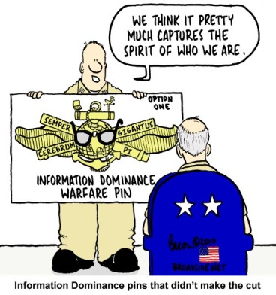
Whether specific and “appropriate” roles for the military services and the Defense Information Systems Agency (DISA) to sustain and operate the Joint Information Environment exist, the Navy has surged ahead with its establishment of its “Information Dominance Corps (IDC).” Let’s just focus on Information Dominance, the Corps (IDC), and what it should be concerned with- and perhaps, by extension, what the Joint Information Environment’s objective should be.
INTRODUCTION—INFORMATION DOMINANCE IS A BIG IDEA THAT SPANS THE ENTIRE SPECTRUM OF CONFLICT AND KNOWLEDGE
“Information Dominance” (ID) is an extremely comprehensive concept. It may be a goal, an end, but “ID” may be neither a means, nor a way, or even a strategy. It does include a very wide range of subjects: War and Warfare, Science and Knowledge, History, Technology, Psychology, Oceanography, Mapping, Charting, and Geodesy, Meteorology, Space, Discovery, Law, Sociology, Warning, Surprise, and Deception (and the “counters” - to all of the above). It is communications, intercepts, frequency management, and power management. It is message management- has Marshall McLuhan’s “the Medium is the message” come full circle?
ID is about mastering the art of “Information Operations.” Joint Doctrine in JP 3-13 defines Information Operations as “(t)he integrated employment, during military operations, of information-related capabilities (IRCs) in concert with other lines of operation to influence, disrupt, corrupt, or usurp the decision-making of adversaries and potential adversaries while protecting our own. Also called IO.” And the publication tells us to “see also electronic warfare; military deception; military information support operations; operations security.”
The Navy’s “INFO DOMINANCE” corps is composed of officers and associated ratings covering many information related capabilities. The Navy’s Information dominance community is a kluge of Intelligence, Cryptologists, Communicators, GEEKS of all natures, Meteorologists, Oceanographers, and timekeepers ( the folks who do that “mapping, charting, and geodesy thing” as I overheard some guys describing the extra weight now being dragged by the old N2/N39 Intel-CRYPTO mafia). Caution: Standby for acronyms.
Information Dominance means conquering the use of the electromagnetic spectrum from control to the environment to protection from interference and intrusion, to jamming and denial to even being able to flip the table on the adversary to create information superiority. As doctrine declares, “the operational advantage derived from the ability to collect, process, and disseminate an uninterrupted flow of information while exploiting or denying an adversary’s ability to do the same (JP 1-02).
It is Electronic Warfare (EW), Electronic Warfare Support (ES) ne’ “Electronic Surveillance Measures (ESM),” Electronic Attack (EA), and Electronic Protection (EP).
ID is networks and communications and NetCentric. ID is “OODA” in every sense of John Boyd’s treatise of how to disorient and overwhelm the adversary through mastery of “Observation–Orientation–Decision–and–Action” sequences conducted so congruently that he “collapses in on himself.”
It is CYBER in the computer networked world as in Computer Network Exploitation (CNE), Computer Network Attack (CNA), and Computer Network Defense (CND) and the network writ large summed up by “DODIN Net Ops” (I can’t even figure out what this one is really).
It is Information Assurance (IA) and all of the “Secs” of security in this environment from COMSEC, ELSEC, and INFOSEC to OPSEC, and….CRYPTO of all sorts. It is EMCON ALPHA (Complete Silence) and EMCON DELTA (NO Restrictions).
It is Intelligence (INTEL) and the INTEL cycle (planning and direction, collection, processing, analysis and production, and dissemination) and now includes “TCPED” Tasking, Collection, Processing, Exploitation, and Dissemination)- within that cycle. And always an assessment mechanism to understand if they are hitting the mark.
It is even MORE. It includes METOC- Meteorology, Oceanography, and precision navigation and timing. It is out of this world- It also incorporates Space. It encompasses “JIPOE”- Joint Preparation of the Operational Environment- to “The analytical process used by joint intelligence organizations to produce intelligence estimates and other intelligence products in support of the joint force commander’s decision-making process. It is a continuous process that includes defining the operational environment; describing the impact of the operational environment; evaluating the adversary; and determining adversary courses of action.
It is getting all to understand/ appreciate/ value what commanders know and need to know ( and maybe need to not know) and learn to see what you see and how they should see things- or how you should see things- to raise understanding/ situational awareness and gain the holy grail of shared situational awareness/ situational understanding. In March Madness, the Coach’s cry in unison “Talk”—In Strike Group ops against a determined foe, that tactic may wind up getting you found, fixed, targeted, and killed.
Its limiting surprises- yet having a range of anticipatory and even pre-rehearsed responses- more detailed that pre-planned—if we get really good, then we can even “own surprise” as my colleague at NWDC Jerry Horton advocates.
It must be Joint and it War.
WAR IS MORE THAN “HEAT, BLAST, AND FRAGMENTATION”-- IT IS A CONTEST OF WILLS -- IT IS ABOUT THE MIND
Clausewitz reminded us that war has a political basis and remains a violent struggle to get the enemy to conform to our will. Sun Tzu noted the objective is to have the adversary come to our way of thinking- either by choice or by necessity. Occasionally, especially in Biblical times, the solution provided was to “just kill them all.” Counselors today offer “When the pain to change is less than the pain of staying the same, then- and only then- will one decide to change.” ID aims to aid the adversary in changing the way they think- or at least the result their thinking produces. Often, the term “Information Warfare” – non-doctrinal- begins to get thrown around haphazardly- even shortened to “InfoWar” on some website as a means to apply “IRCs” (Information Related Capabilities- remember?) against the minds of our opponents.
Some in “InfoWar” speak of “Hardware, Software, and Wetware.” Hardware includes the boxes, wiring, circuit boards, and systems; software includes the programs and routines that make the data flow happen; while “Wetware” represents the minds of the consumers- in our specific case- the commanders. Moreover, it includes the minds of those we may work against as well as those we work with. All of that ID Ability must remain focused on Always seeking a better advantage – or “vantage” to advance our cause or delay the adversary—or just figure out what they may be up to. We must “Beat” them…. In every domain and every dimension. Not only physically through what I call “Heat, blast, and fragmentation warfare” but we must get them to change their minds- stop fighting to do things their way- mentally, morally and, dare I say, spiritually.
How can we equip our commanders to succeed at command in the 21st century ? We say we must be “better” faster-cleaner-easier understood- all on the same picture, and aligned. To succeed in any branch it takes unbridled curiosity- and always wanting to learn Why?—(And even Who, What, Where, When, W---, How and now How much will it cost $$??)
SO QUO VADIS INFORMATION DOMINANCE? THREE CONCEPTS, THREE PRODUCTS, AND THREE QUESTIONS
So what should the ID corps be concentrating on to best influence the “fight.” To center their efforts to guide commanders, I submit three concepts, three products, and three questions. They need to have a solid grounding in the concepts before they ever open their mouths. They must strive to develop, advance, and continuously refine tools that enhance commanders’ Battlespace awareness, confidence, and decision-making. And they must be in continuous pursuit of refining the answers to three specific questions from the planning process.
They all need to understand the detailed concepts of O-O-D-A, various advanced models of decision making such as Klein’s Recognized Prime Decision model, Gladwell’s Blink, and Cohen, March, & Olsen’s Garbage Can, and remember always Clausewitz’s three intertwined elements- Passion, Reason, and Chance.
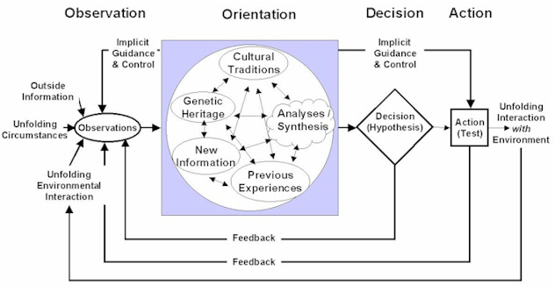
They need to understand Boyd’s O-O-D-A in all of its parts- not the basic “OODA for Dummies” version but the version below:
To learn more about O-O-D-A in depth, explore works by Chat Richads and Frans Osinga.

A key aspect of Command and decision-making is “Understanding.” The Royal Navy actually has a doctrine publication titled “Understanding” that describes “Understanding” in the context of decision-making: “understanding is the perception and interpretation of a particular situation in order to provide the context, insight, and foresight required for effective decision-making as well as manage the associated risks and second and subsequent order effects. (JDP-04)
The ID community has three main products that commanders care about: the Common Operational Picture (COP), “my” (the commander’s individual) CCIRs since we all think differently- yet need to “discover” similar truths), and tools to make our systems smarter in terms of associating patterns, words, connections, contours, etc. Many geographic information system (GIS) mapping algorithms can be applied to data analysis in looking for patterns and predictability when we are trying to discover enemy/ adversary potential COAs. I think the ID community needs to concentrate on helping commanders believe in the COP. Now how do we raise our commanders’ collective confidence in the common operational picture? They need to help commanders articulate their CCIRs more completely and understand what they do really need to know. How will the ID corps know that? Would an understanding of the Knowledge Box help?
The Knowledge Box
Take two statements: I know and I don’t know. Now, cross them into each other so you have four expressions and lay them out into a matrix form. One aspect of Information awareness is to move as much Knowledge as you can into Quadrant I- so you “Know You Know.”

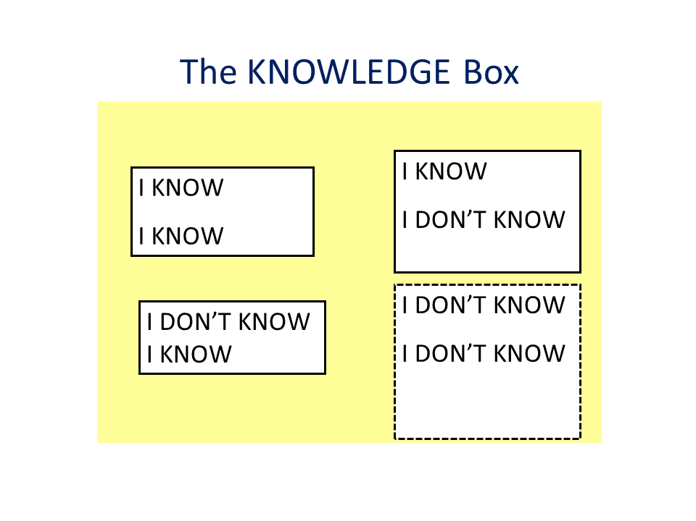

The four boxes yield:

I - I Know I Know- That is recognized knowledge- You “know what you know”.

II - I Know I Don’t Know- That is a recognized gap- You understand and have identified what you know you must learn about. It’s what we “Google for.” It’s safe because you have identified a requirement which must be met.

III - I Don’t Know I Know- That is tacit/ intuitive knowledge. From your Background, Genes, DNA. You function with some knowledge that you do not recognize you already have. It’s safe because you haven’t had to recognize what you know but don’t yet realize.

IV - I Don’t Know I Don’t Know- That is “ignorance.” Not necessarily a “Bad”, but one must realize that always there are things which are known by others, which you have no knowledge of- and you don’t know them. It is dangerous, because the tendency is to assume you know “All About It” when in fact you don’t really know much at all.

A key take away is that the last quadrant is always bigger than you can even imagine.
Boyd ‘s OODA loop often challenges commanders to execute the processes more rapidly and completely thus allowing greater speed of action causing the adversary to become confused, disoriented, and unable to cope. Thereby, disrupting his OODA cycle, and yielding him to your will. But how will we know we have achieved that desired effect? We will have to know/ understand what it looks like! That where the concept of the Knowledge Box comes into play with OODA and knowledge of decision models. How did the adversary arrive at their conclusion? Did they apply Blink, or RPD, or even employ a “Garbage Can” (Cohen, March, & Olsen, 1972) approach?
Commanders have a responsibility to produce a commanders intent and ensure it is understood. Doctrine gives guidance as a three paragraph statement of Intent as a concise, narrative expression of the purpose of the force’s action, the desired results, and how actions will progress toward that end state (concept of operations). But can anyone truly pass understanding in three paragraphs? Understanding must be built on trust and trust only stands on relationships.
One of my old CO’s told a story to demonstrate the concept of trust: He started with two Sailors, each given an assignment. The first, always would not only complete the assignment, but would do it on time and even better than you expected. The second, often forgot what the assignment was, had to be repeatedly reminded and when he reported “Done”- the job wasn’t quite right- So my CO asked- Which one do you trust? I offered the First- He retorted-you trust the both- You trust them to do what they have always done. Trust is a relationship issue. So if we want to be able to trust subordinates with carrying on what we expect them to do, we need to know that they will do what we want them to do when we can tell them. How can we impart that knowledge?
Boyd’s Treatise on Command and Control from 1987 on Slide 18 shows 3 blocks:
Message
Expose individuals, with different skills and abilities, against a variety of situations—whereby each individual can observe and orient himself simultaneously to the others and the variety of changing situations.
?-Why-?
In such an environment, a harmony, or focus and direction, in operations is created by the bonds of implicit communications and trust that evolve as a consequence of the similar mental images or impressions each individual creates and commits to memory by repeatedly sharing the same variety of experiences in the same ways.
Beneficial Payoff
A command and control system, whose secret lies in what’s unstated or not communicated to one another (in an explicit sense)—in order to exploit lower level initiative yet realize higher-level intent, thereby diminish friction and compress time, hence gain both quickness and security.
By continuing conversations when we- the commanders- have time with them—and we have to make that time. Seniors who don’t make time to teach train coach their subordinate commanders will not have any faith that their subordinates are carrying their intentions even when they cannot communicate. Boyd concluded that a more appropriate model for Command and Control would be “Appreciation and Leadership.
Formally the term is “CCIRs” commanders critical information requirements- these are the things that commanders have determines they need to know. and they can come specified but also will be implied by the myriad of staff directed RFIs/ questions and directives that augment the commander’s initial guidance. Commanders must practice and get better at articulating their CCIRS. Our “systems” have to be made smart enough to capture CCIRs and prioritize them so when we get into anti-access/denied-degraded communications (A² D²) environments we already understand what information we don’t get passed 1 time per day rather than once per second.
What we can do now to build useful “ID” traffic analysis and algorithms during all exercises to discover information flows and paths that can be reduced in update frequency to lower the load on reduced bandwidths.
Halsey papers are a good reminder that there truly is a deep fog of war despite what Admiral Owens book’s title of Lifting the Fog of War—more information and more data available has only caused it to thicken.
SPEED of Decision is part of the decision- but decisions need also to be right--- so that actions started can advance positive effects rather than expose us to delays or worse, detection!
So the ID community must help commanders build their appreciation of the whole situation- and learn to value all of the contributions for success. By keeping all engaged in the conversation, before the battle to have confidence going in; during the battle to sustain confidence while things are beginning to fall apart, and after the battle to pull things together to drive on to victory. Naval Regulations Section 0851. Actions With the Enemy. The Commanding Officer shall: Before going into battle or action communicate to the officers of the command, if possible his or her plans for battle or action and such other information as may be of operational value should any of them succeed to command.
Planning must be embedded into our routine. A simple process can help us center our priorities from the strategic to the operational to the tactical- and even connect them. Solve these three questions- in order at every level:
- What do you really have to do?
- How well do you have to do them?
- What help do you need from outside the ID community?
Starting from the Top, working down, ask these questions, over and over. As you do, you will build the network of how the IDC should be organized, connected and how the information should flow to support the warfighters. Ofter, from the highest level, there are similar requirements that when solved for one Combatant Commander, can be applied to all the others- Precision Navigation and Timing (PNT) or Global PosiGPS for example, or Mapping Charting and Geodesy issues. Asking these questions starting at N2/N6 in OPNAV would show how it connected and interfaced both within OPNAV and through the Fleets and SYSCOMS and even TYCOMS.
Moreover, this process could enable the interface with the new ID TYCOM with other TYCOMs as it assumes its rightful as a supporting command to forces engaged in Fleet Operations man, train, and equip issues across all other TYCOMS, as well as its own forces who serve ashore and afloat.
Information Dominance is a huge concept. At least I have given them an idea of what they can do to come together to support the commanders and the warfighters and know they have collectively done their all.

References:

